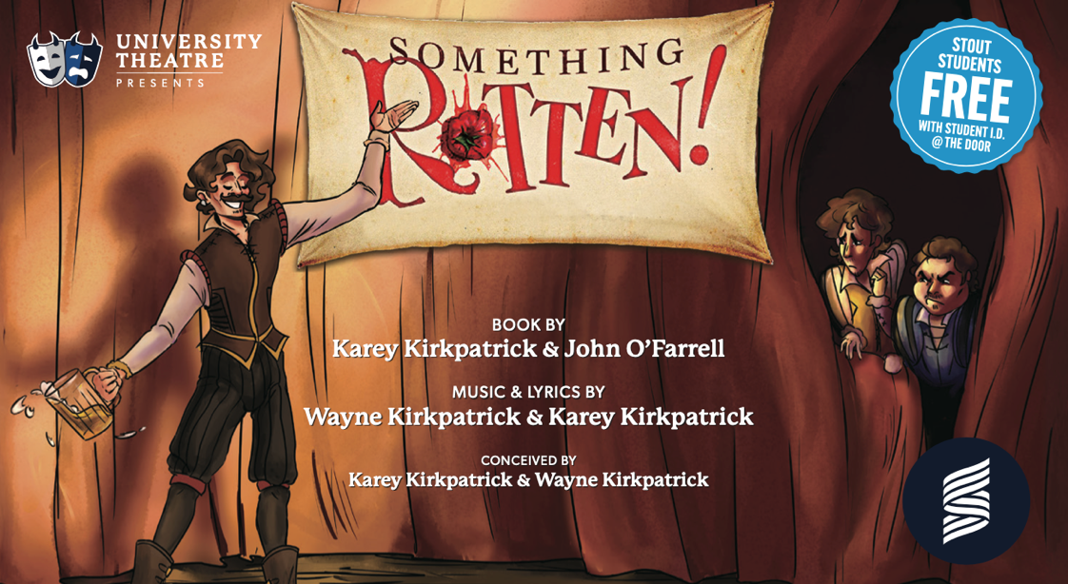

UW-STOUT
Spring Musical 2026
Audition Materials

Everyone interested in either being on stage or off, please fill out the AUDITION FORM / SIGN UP / AVAILABILITY before auditions.

Please PREPARE all characters for the 4 sides of reading cuts, the Tap routine (This will not be taught at the audition, use the link provided), and one of the singing cuts before your audition.

This is available on the next pages. Not every character in this production will have to Tap, so you will also learn another short, choreographed 32 counts of movement as part of the audition (Again, this isn’t Tap movement.)

Come to your audition time prepared to read, sing, and dance. Every year we get the question, “What does prepared mean?” To answer this question, prepared means: We want to see you succeed. We want to see you at your best. We don’t want to see you stumble over the readings or singing cuttings. This is why you get them in advance, so you have time to prepare them. This is your chance to show us your skills. Memorization is not a requirement, but preparation is needed.

Please wear clothes you can move in well; Hard-Soled Shoes (not sneakers) for the Tap portion of the dance audition, as well as shoes you can move comfortably in are needed for the dance audition and clothes that do not inhibit your ability to move freely.

TAP Audition Instructional Video (Link will be uploaded by Dec. 20th, 2025)
Please PREPARE both parts for all the following reading cuts before your Audition.

1st Reading Side (1 page):
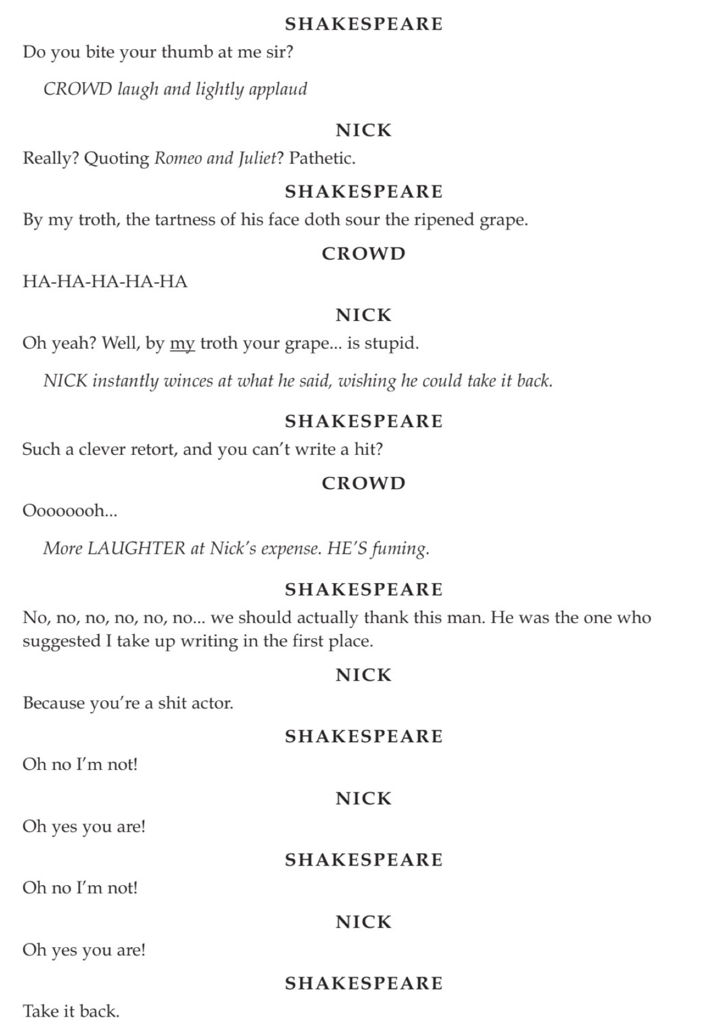
2nd Reading Side (2 pages):
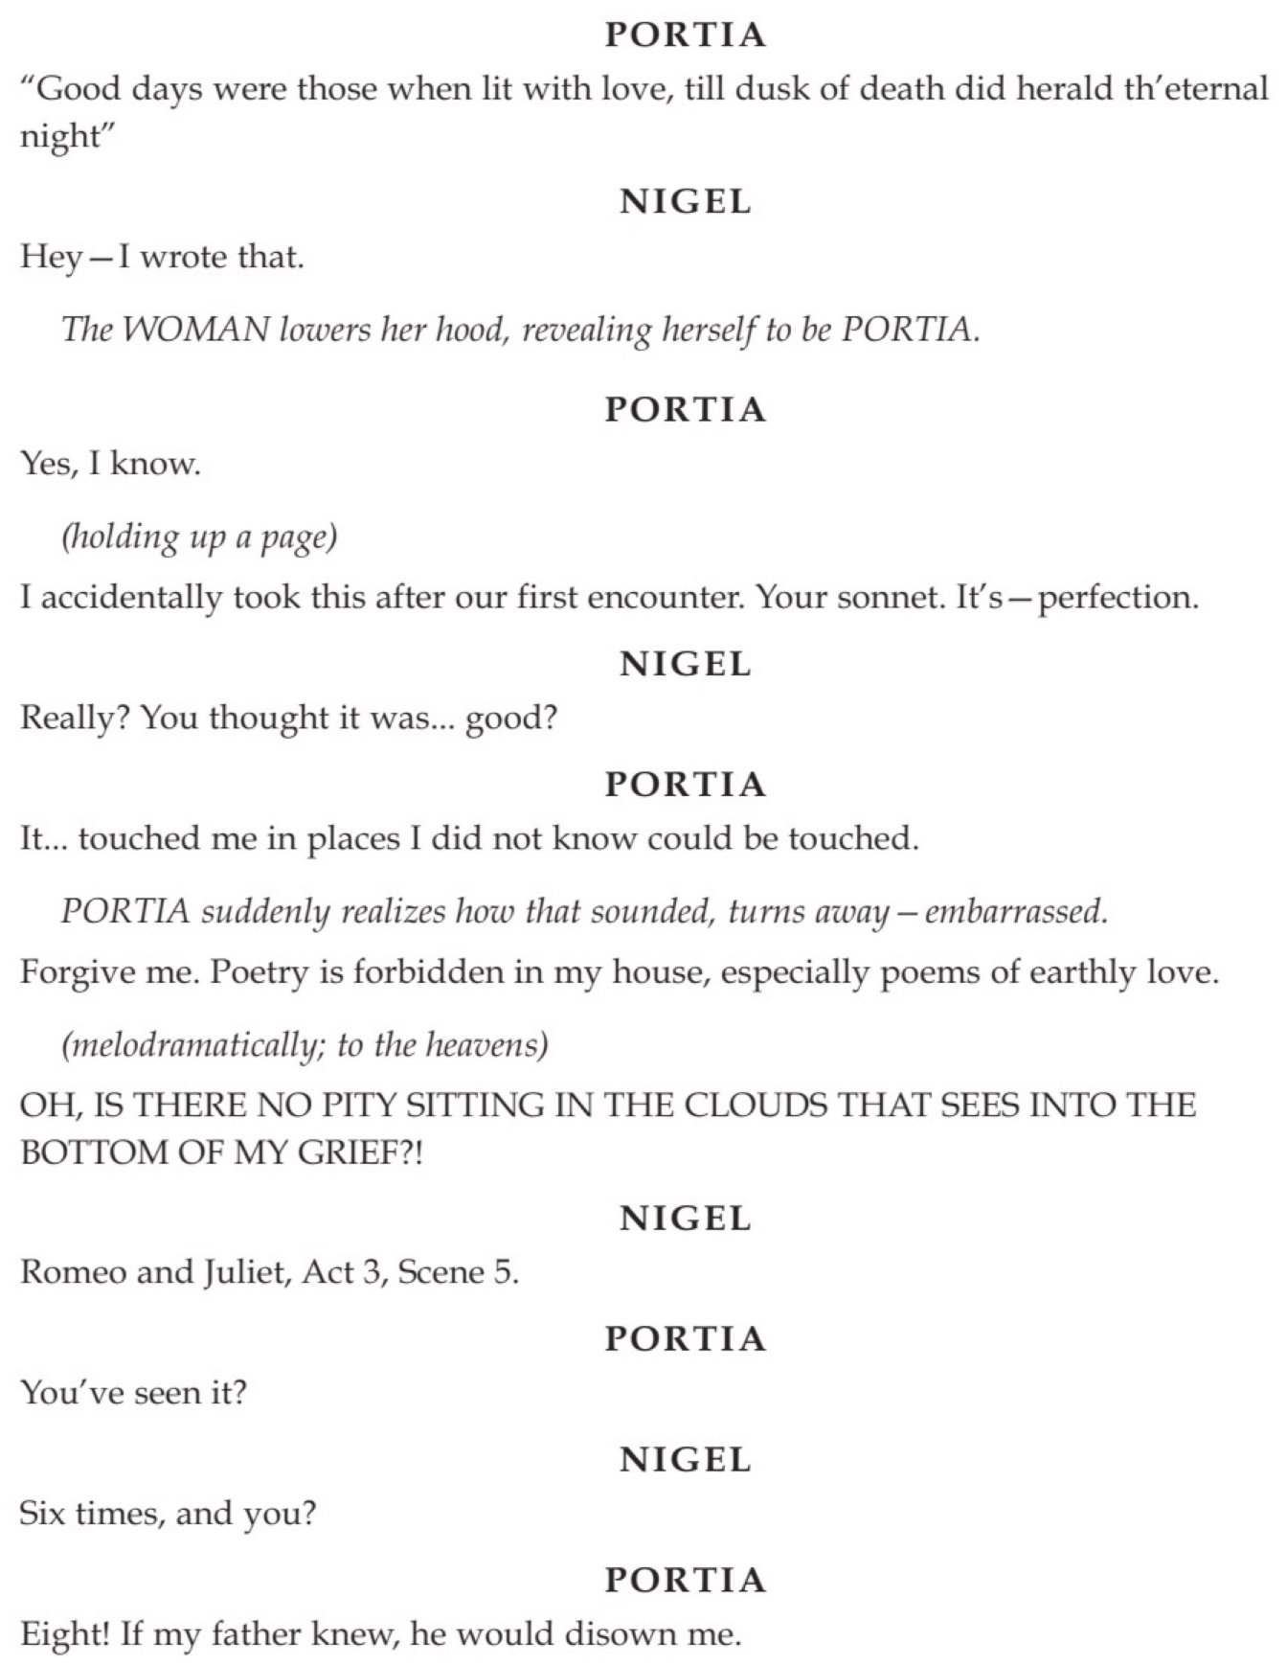

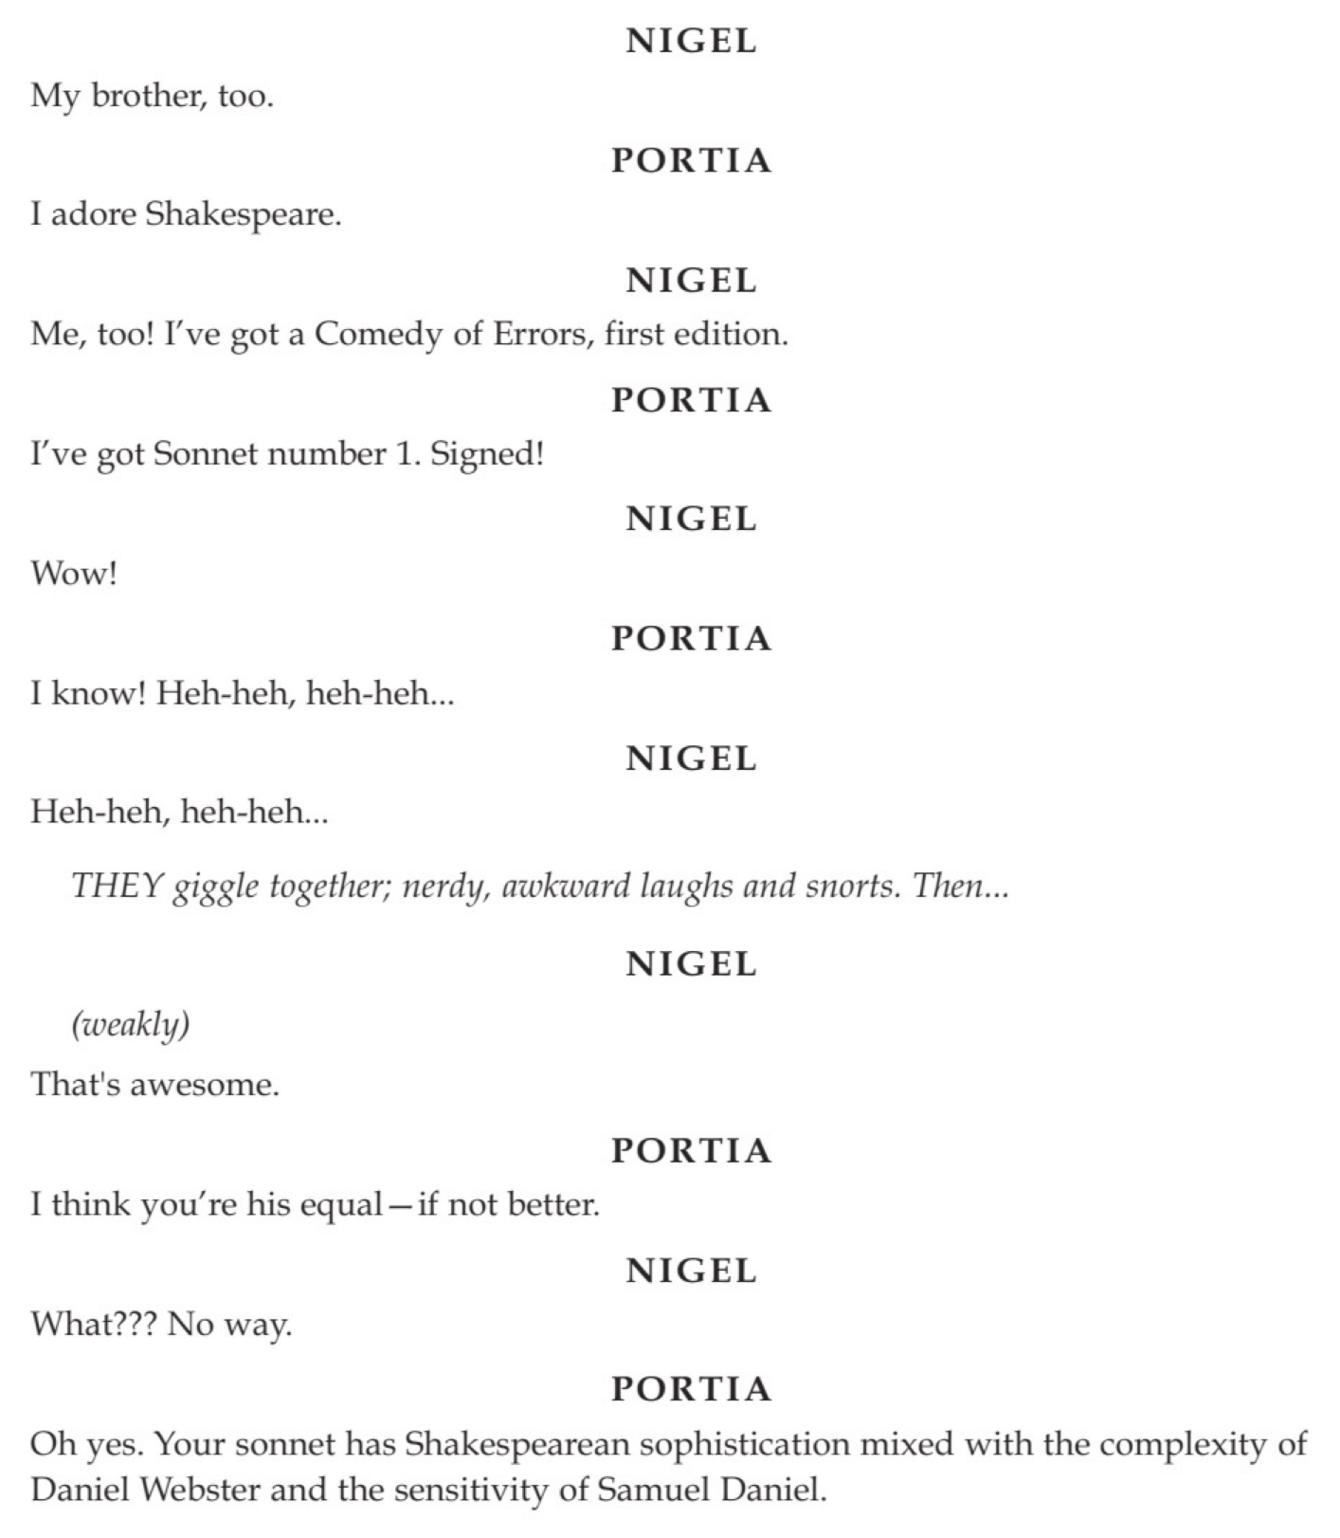

3rd Reading Side (2 pages):
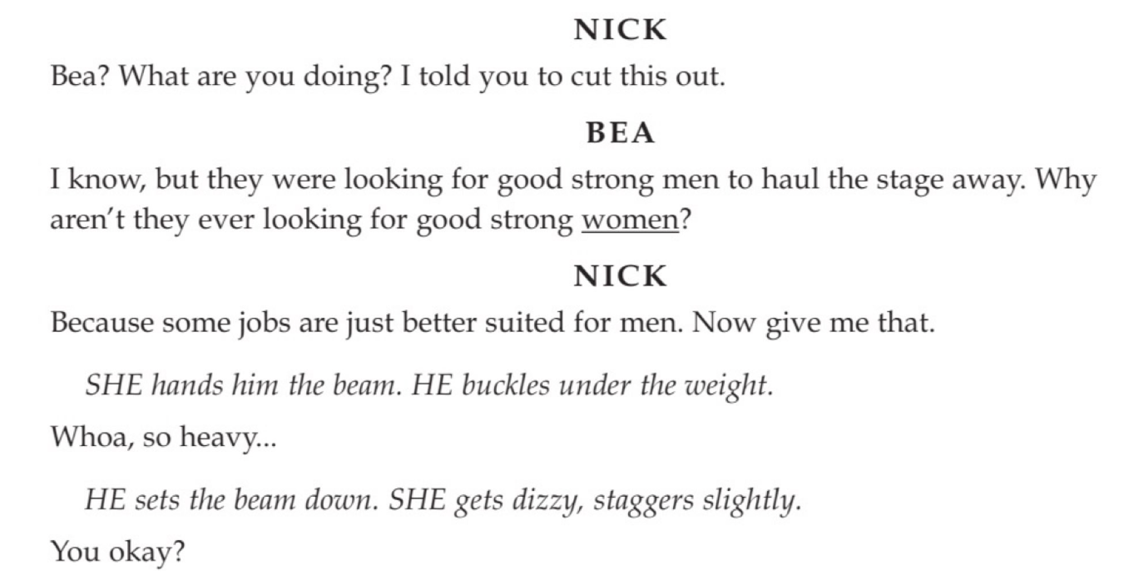
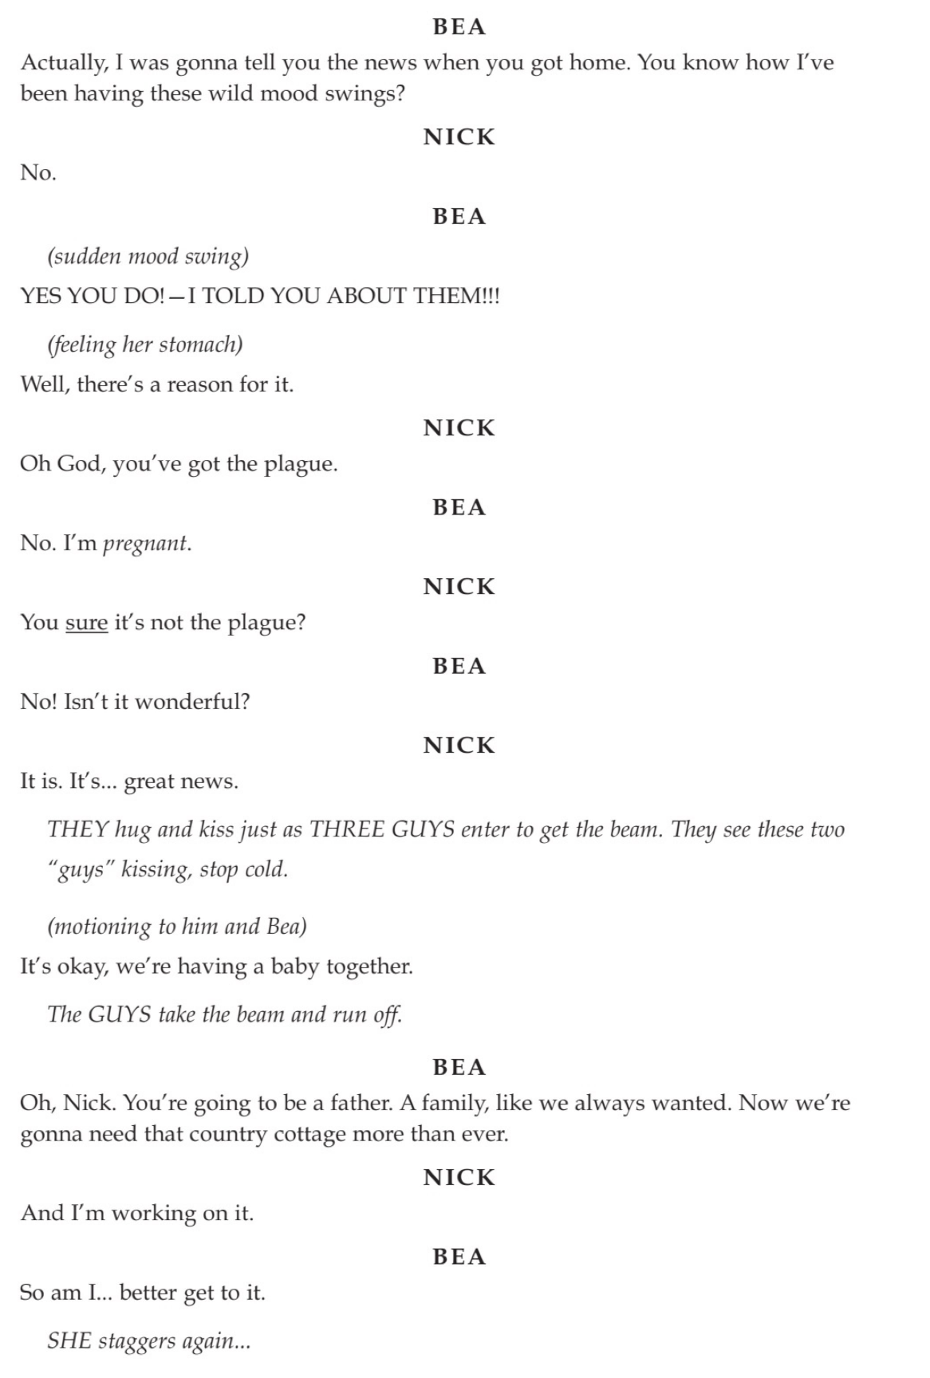

4th Reading Side (1 page):
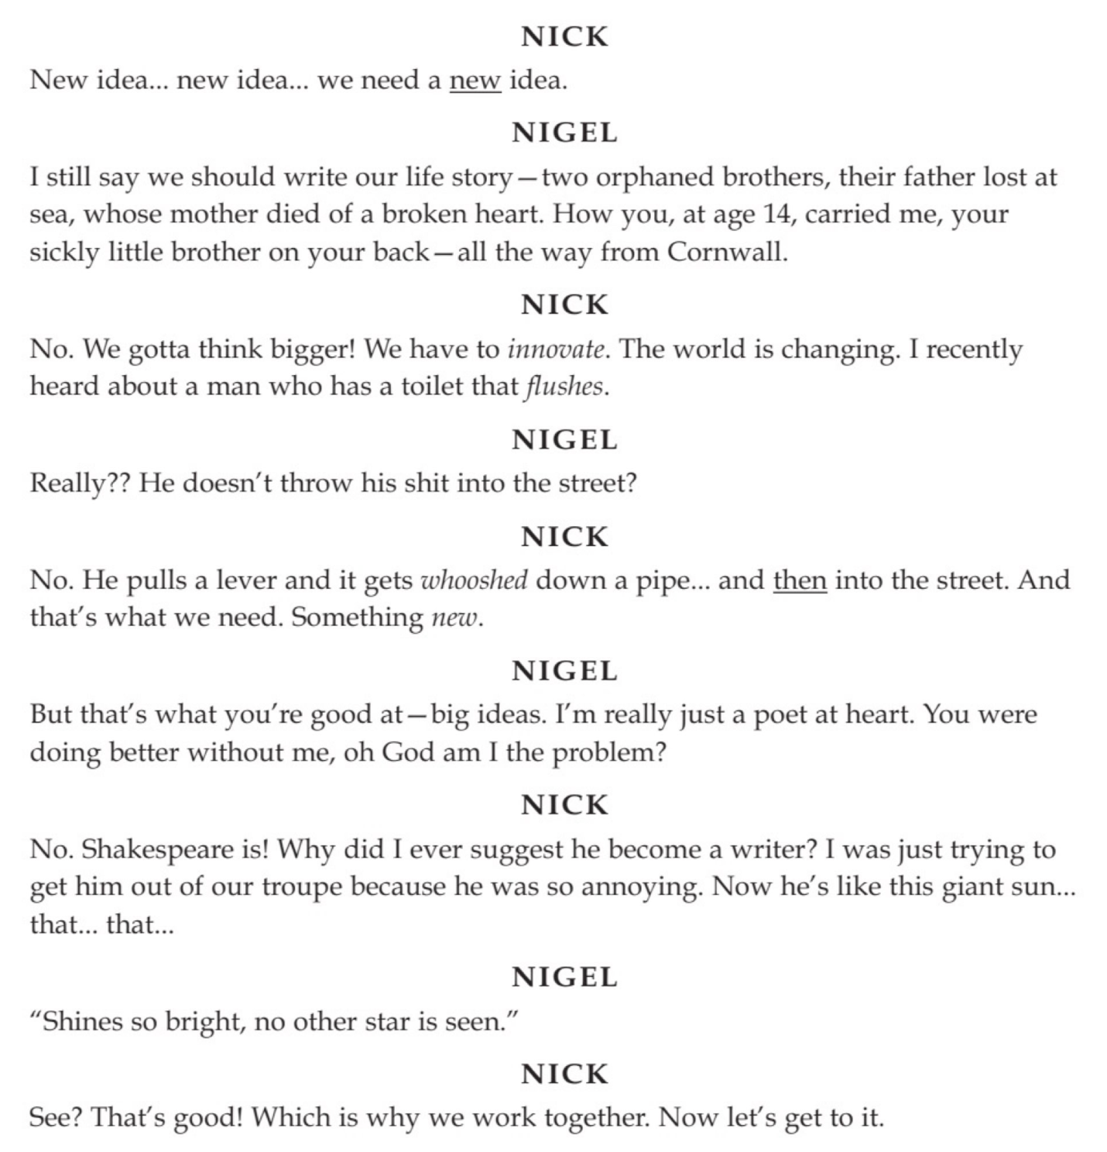

.

Please PREPARE any one of the following singing cuts in your comfortable octave before your Audition. You may be asked to try another as well, so please be familiar with any of them based upon voice part. Choice of the Following:

Choice 1: Suggested Soprano song cutting: from “I Love the Way”

Example Track Rehearsal Track Audition Track (USED IN AUDITION)

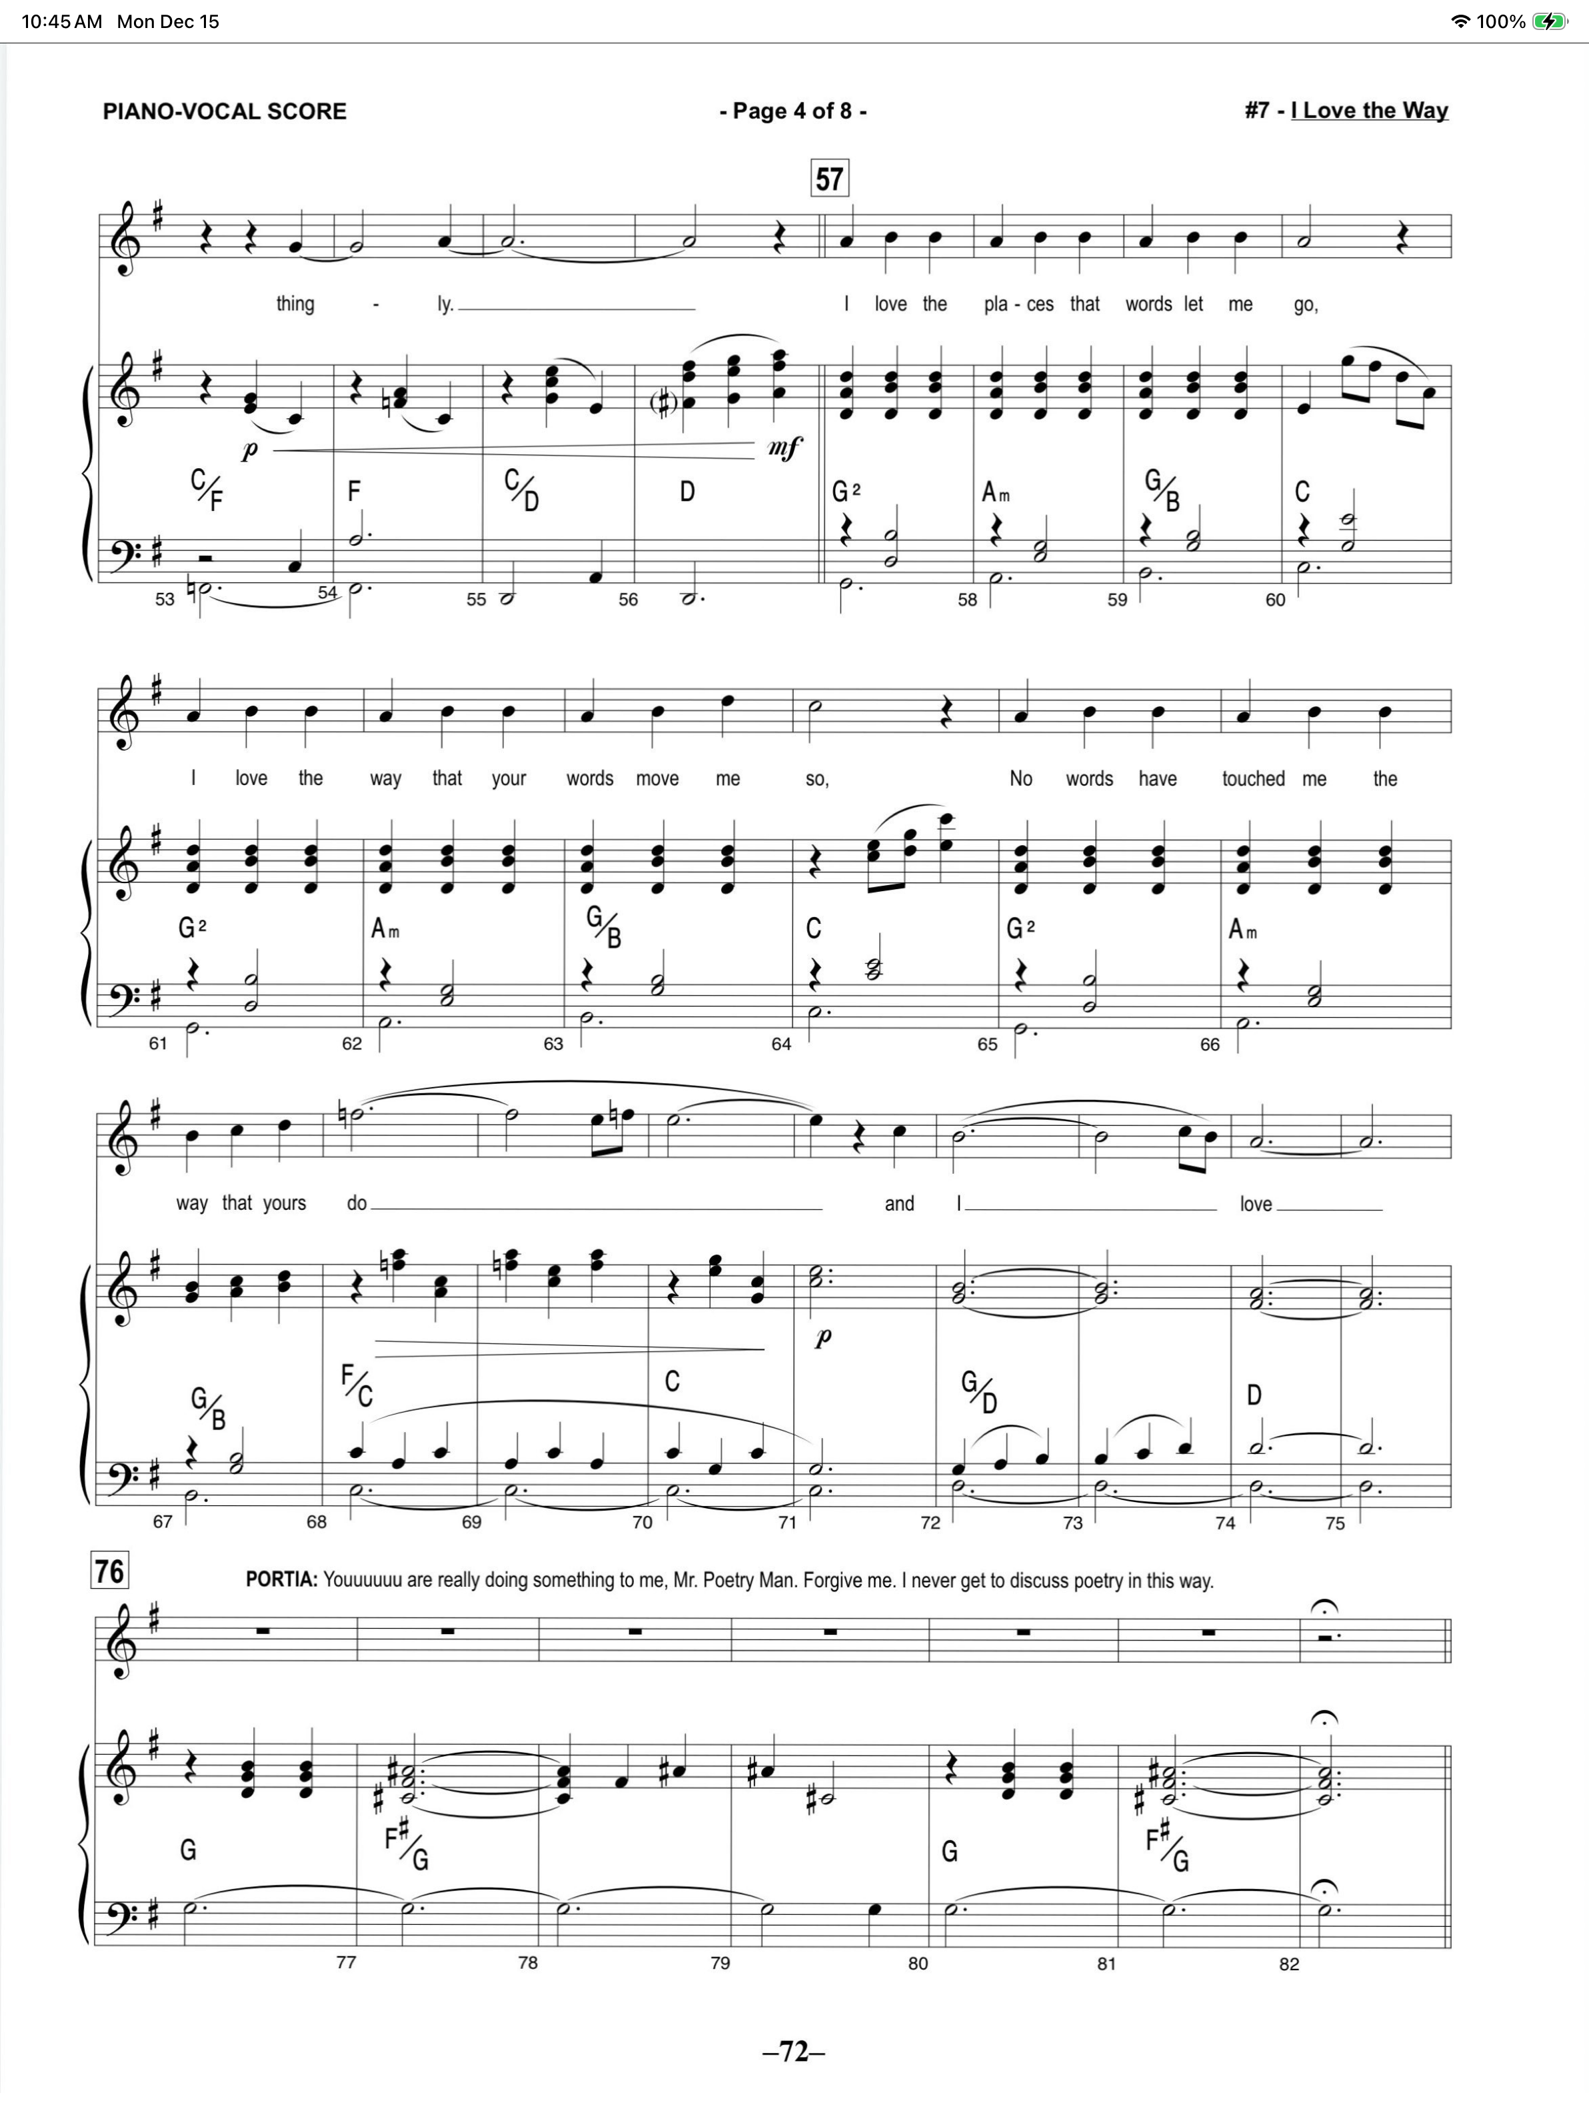

Choice 2: Suggested Alto/Mezzo-Soprano song cutting: from “Right Hand Man”

Example Track Rehearsal Track Audition Track (USED IN AUDITION)

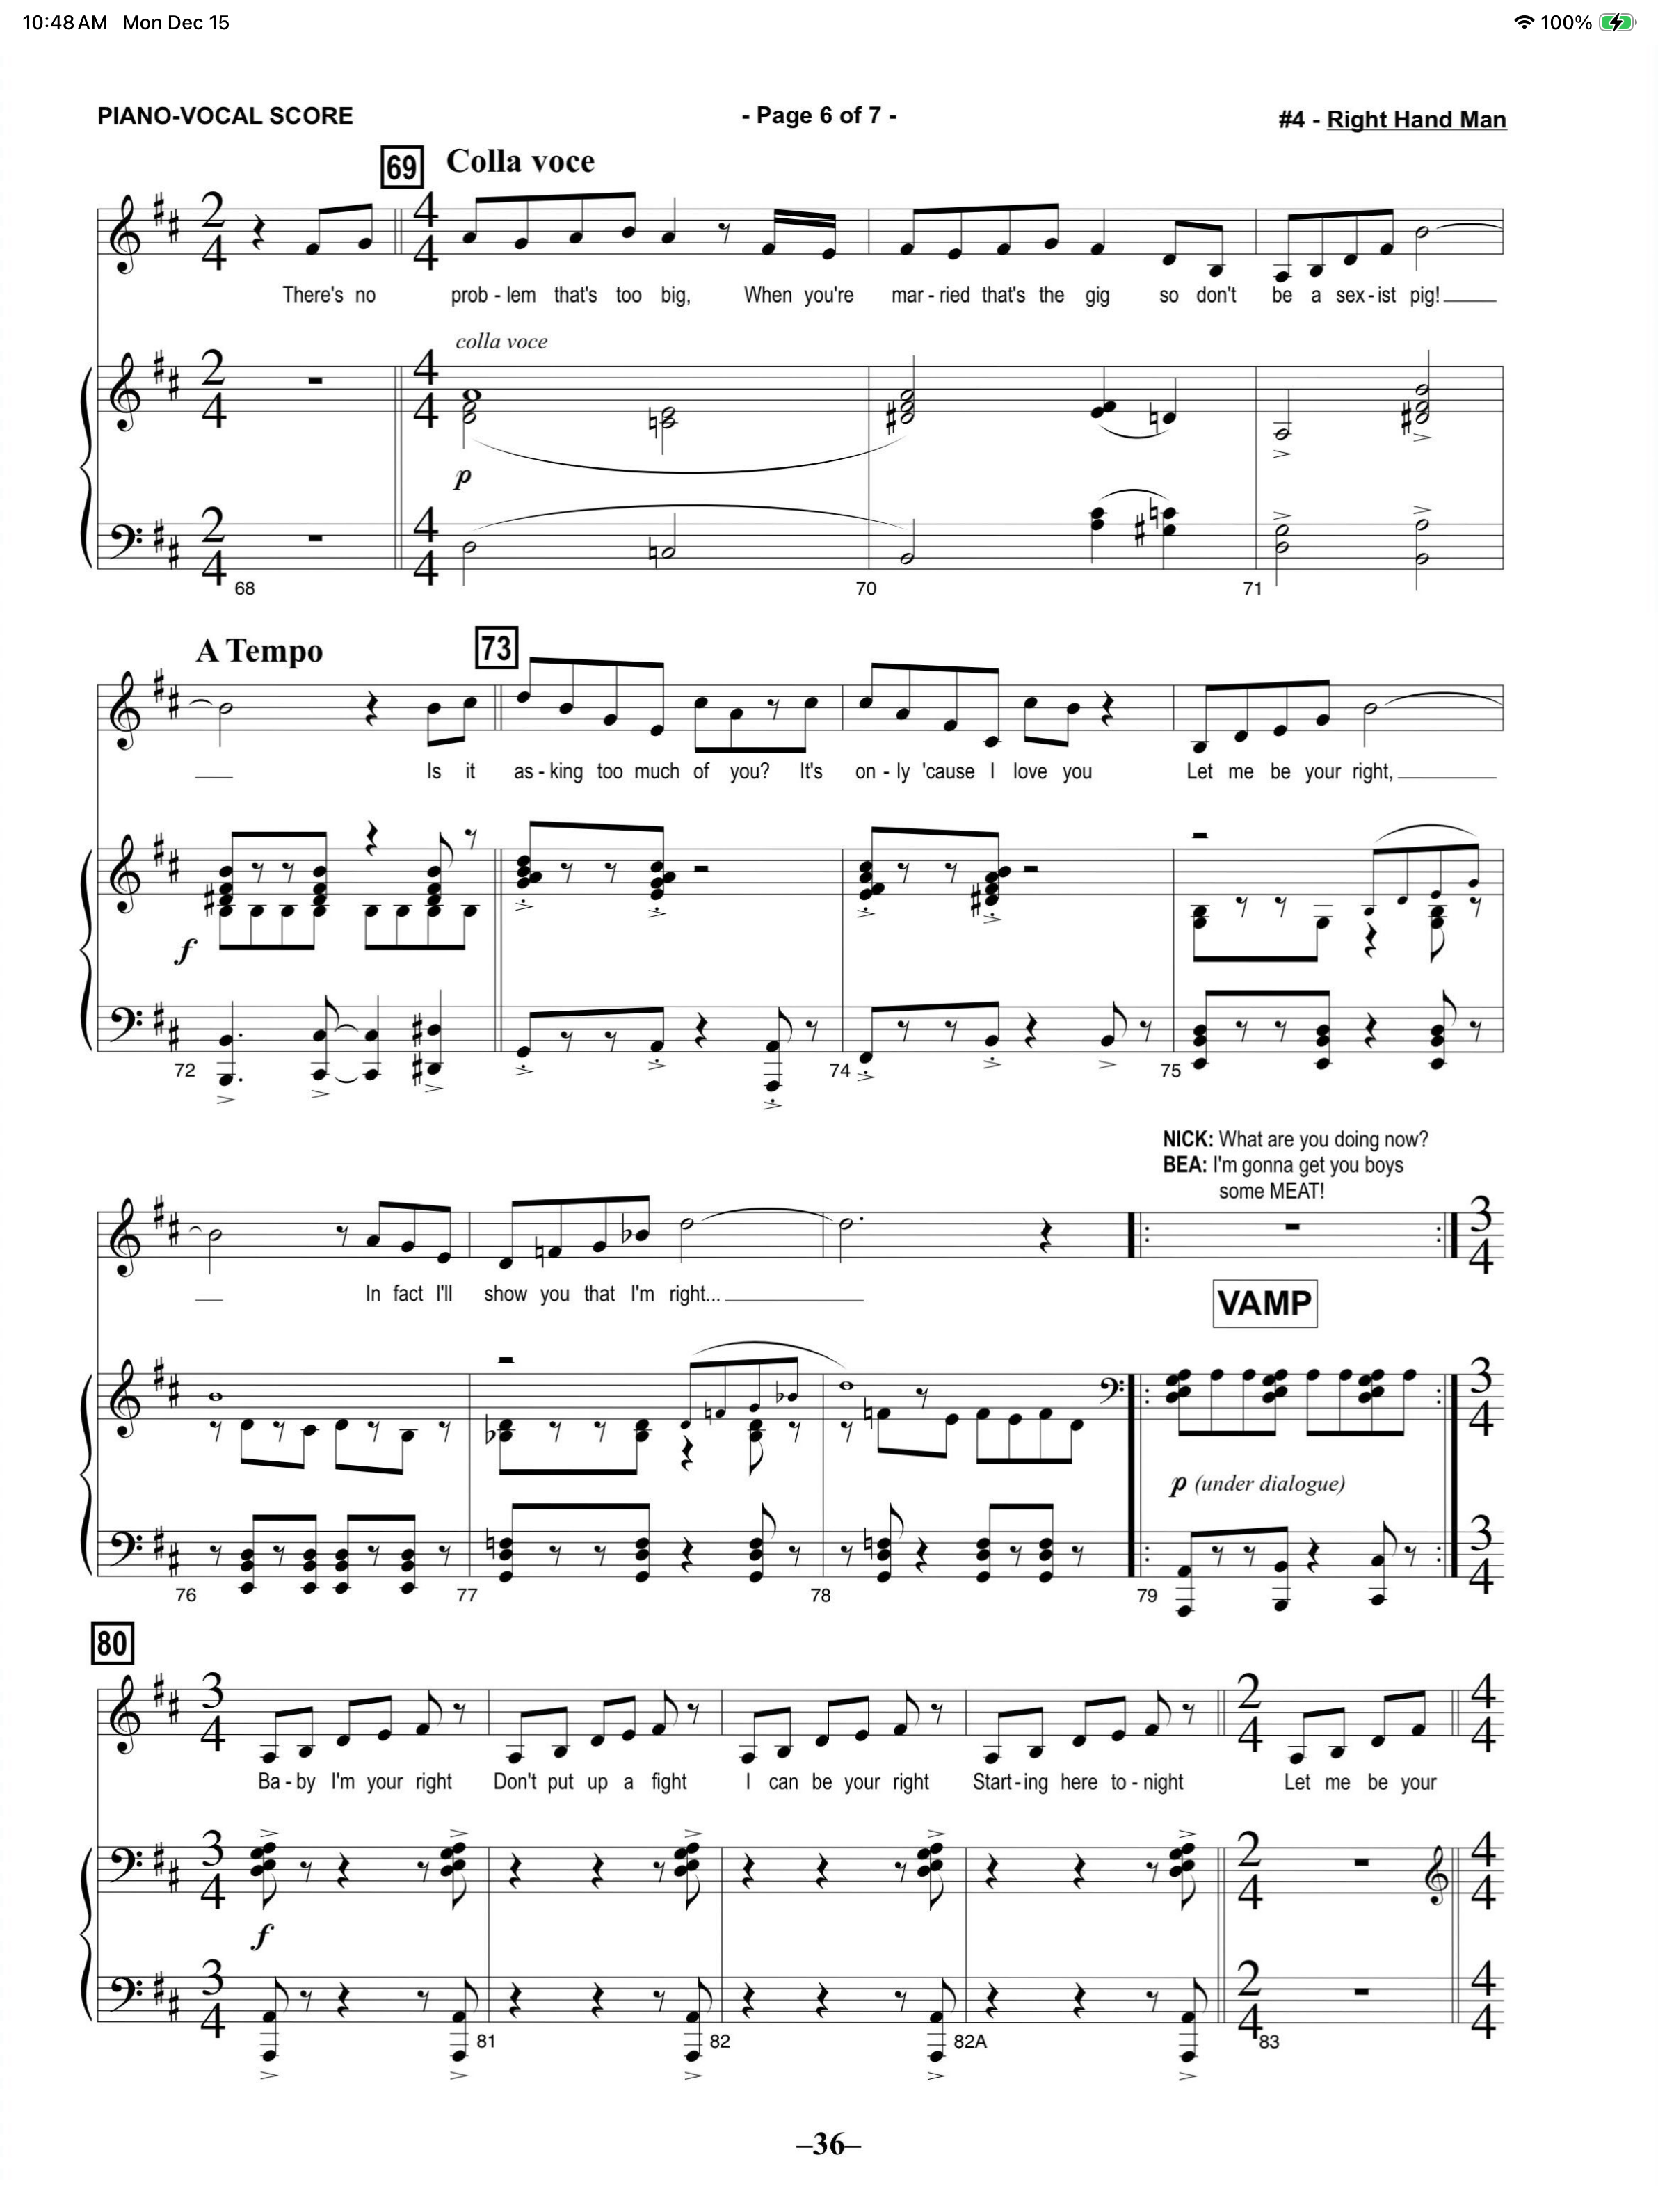

Choice 3 (3A & 3B): Suggested Tenor songs’ cuttings please prepare both 3A and 3B:
Choice 3A: “God, I Hate Shakespeare”

Example Track Rehearsal Track Audition Track (USED IN AUDITION)

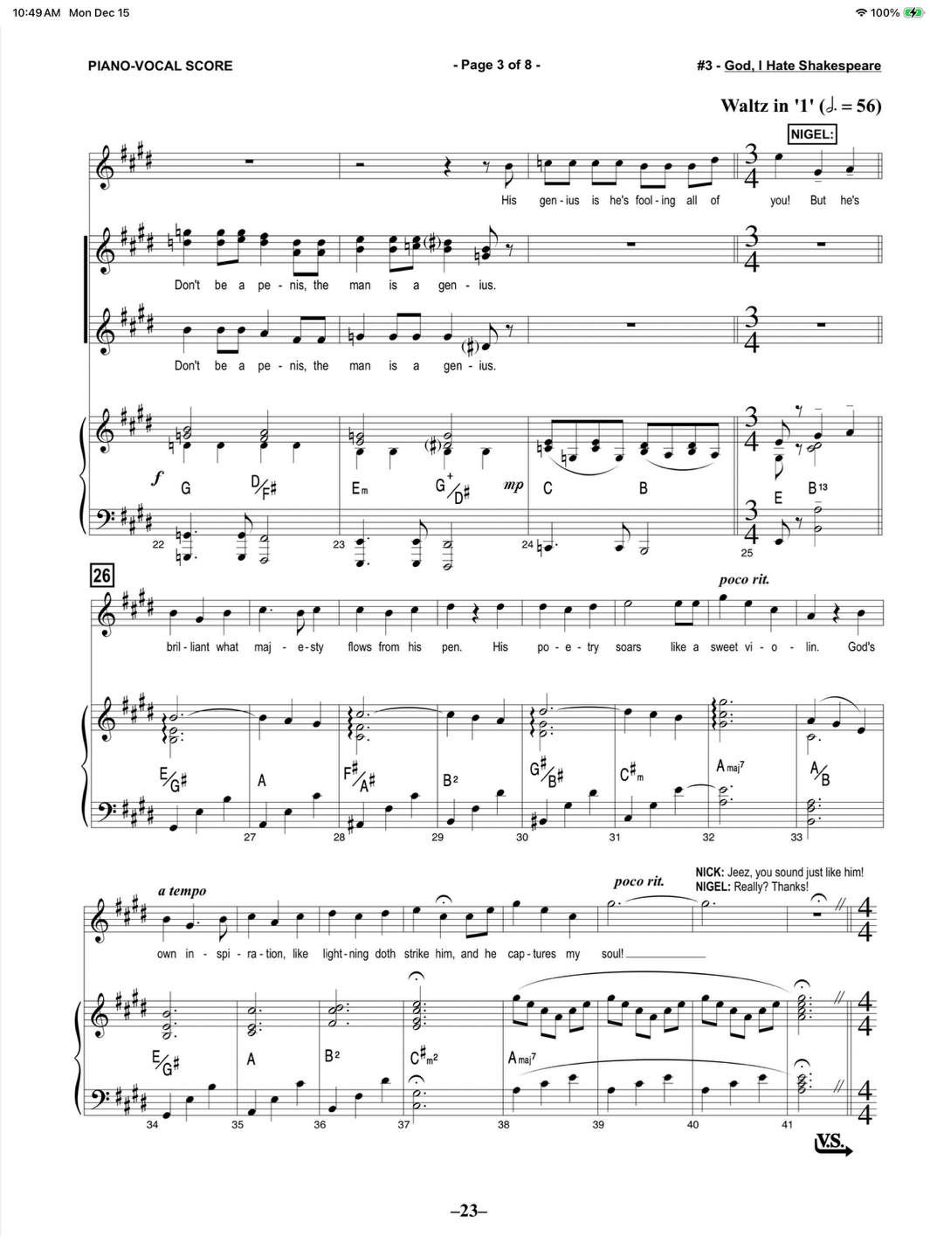

3B: “Will Power"

Example Track Rehearsal Track Audition Track (USED IN AUDITION)

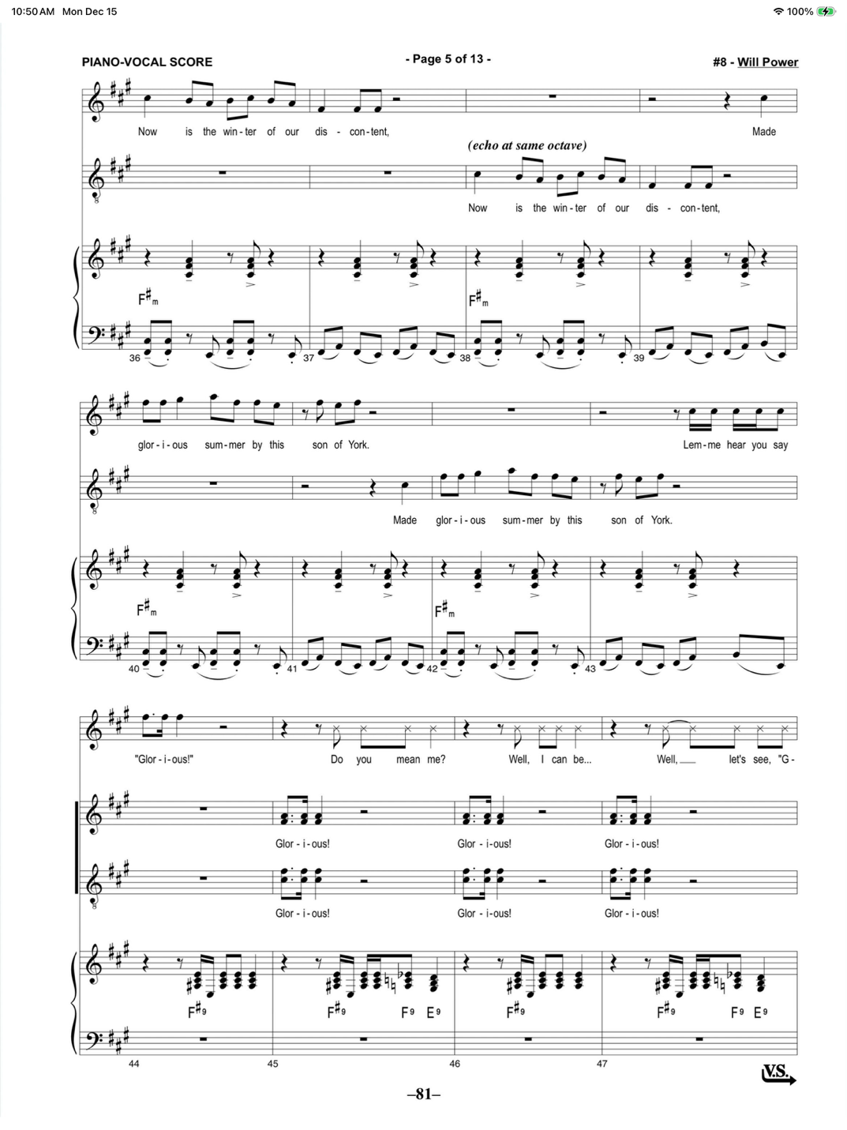

Choice 4 Suggested Bass/Baritone song cutting: from “Bottom’s Gonna Be On Top”

Example Track Rehearsal Track Audition Track (USED IN AUDITION)
(Link will be uploaded by Dec. 20th, 2025)
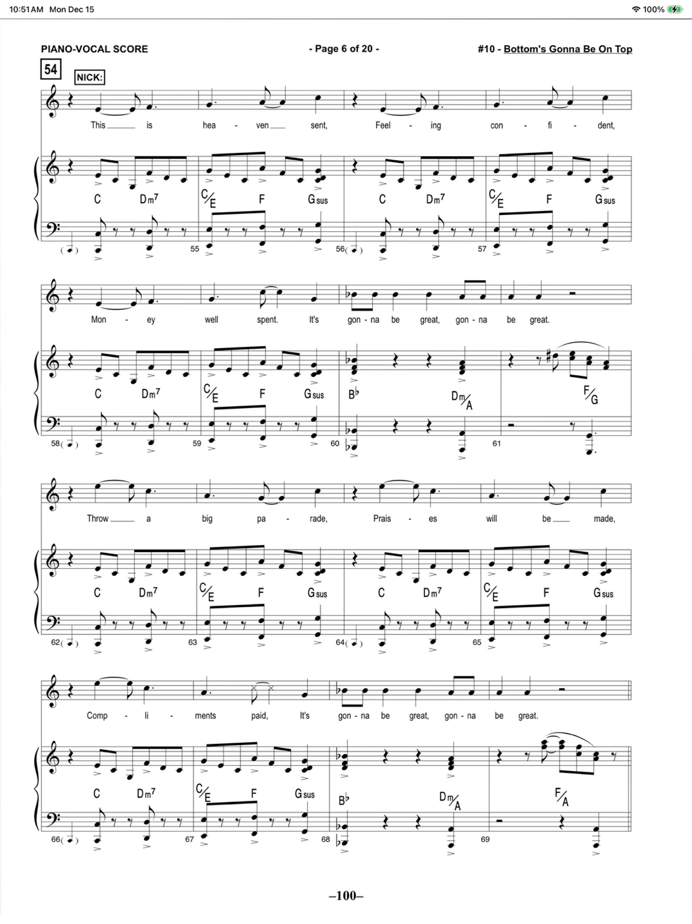

Callbacks:

Some of you may be asked to attend a callback audition.
More information regarding callbacks will be shared by January 20th, 2026

