Student Org use of CONNECT’s e-commerce feature:
Student organizations are welcome to use the online credit card sales features in CONNECT when the following conditions are met:
- They have set up an Agency Account with the Business office.
- A representative has completed the training within the current academic year.
- The organization is in good standing with the Involvement Center and its policies, procedures, and requirements (One key requirement is to have your agency account name on file in your recognition paperwork).
- The organization is in good standing with the Stout Student Association and code of conduct.
- The organization agrees to follow fundraising guidelines.
- The organization agrees to pay applicable sales taxes to appropriate agencies (See section 5 for a list of the most common items student orgs use.)
- Solicitation of donations are SHOULD NOT be done through this site unless the donors do not need. See Foundation account procedures for donations.

Section 1 – Agency Account Set up/Maintenance
- If your organization already has an agency account, make sure you:
  - Have an updated signature authority on file with the business office listing the people who can make withdrawals.
  - Are in good standing with the business office for cashed checks and proper accounting procedures.
- If your organization does not have an agency account – you need to:
  - Set up an agency account by filling out the forms here: https://liveuwstout.sharepoint.com/sites/2024/Business%20and%20Financial%20Services/Agency-Request-to-Establish-Acct-Form-A.pdf?csf=1&e=n06BWc&cid=e790190f-4e45-4eea-b95a-b26cc48201eb
- Typical agency account procedures:
  - Making a withdrawal request at the counter: https://liveuwstout.sharepoint.com/sites/2024/Business%20and%20Financial%20Services/Agency-Withdrawal-Form-B.pdf?csf=1&e=4EV1ME&cid=3abfadc3-3200-4533-a158-7f5ee7c70b45
  - Making a cash deposit at the business office: https://liveuwstout.sharepoint.com/sites/2024/Business%20and%20Financial%20Services/Agency-Deposit-Form-C.pdf#search=Agency%20Account
  - Setting up online sales in CONNECT – see section 2.
  - Accessing funds from online sales – see section 3.
  - Paying fees for online sales – see section 4.

Section 2 – Setting up online sales in CONNECT
It is important to remember that when doing online sales, we have no opportunity for refunds, and everything goes live immediately as default so you may want to consider making the set ups only visible to org leaders until a sales launch.

Dues example – but not the recommended path:
- When you set an amount on the settings page in the membership tab it automatically begins to charge people who join your group. You may to put your membership dues in an event instead location if you do not want folks to not be able to see your group unless they are paid members.
- When you put a membership dues amount in make sure it is clear how long those dues are good for by setting a membership expiration date (i.e. if dues are for a semester or a year set the duration to reflect that).
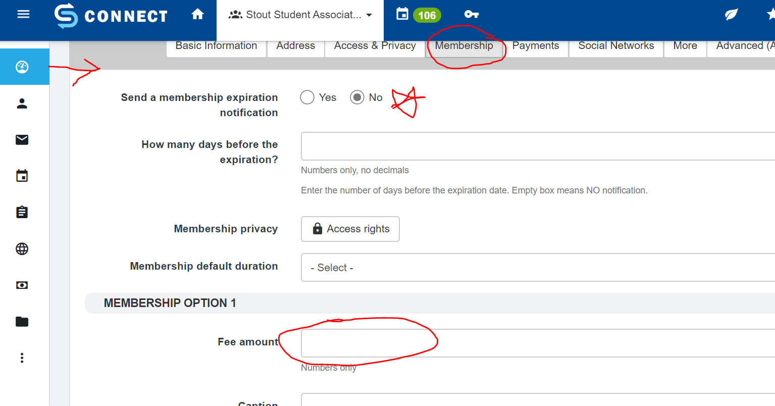

Merchandise example (Bake sale, t-shirts, etc.):
- Create an event just as you would any other event in CONNECT
  - Pay special attention to your start/end dates/times for when you want the sale to open and close – these dates can be different than the event itself
  - Also pay attention to who can see it – unless you’ve planned to ship these goods elsewhere.
- Within the Registration Options is where you will enter in the different items available for sale.
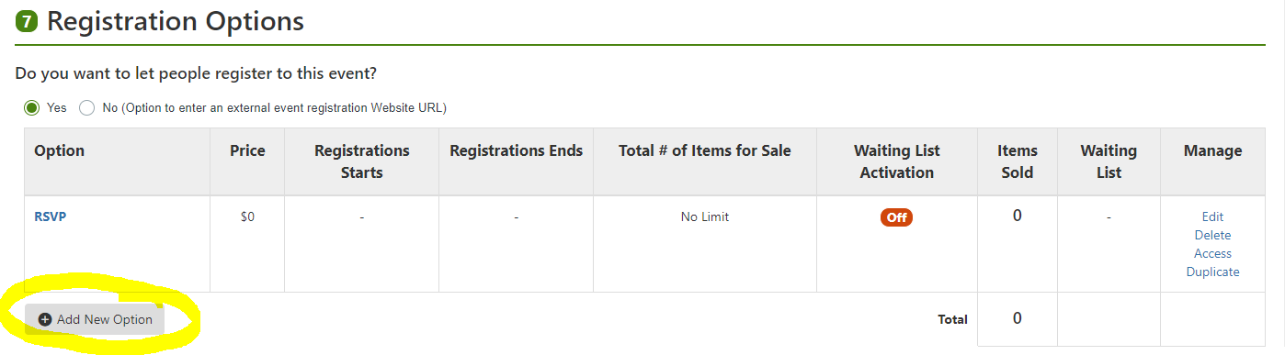

Item options:
    - Item name – describe what you are selling – be specific if you are selling similar items, you will want folks to be able to determine if they are buying the correct item (i.e. Red T-shirts size Small, vs shirt)
    - Number of each item type that are available if there is a limited quantity
    - DONATION – so there is a button to set up a donation- please know that you can set an option for donations, but at this time it is NOT sent to a foundation account that will be tax deductible – if you need that option please accept check or cash only and deposit into a foundation account using a foundation form
    - Quantity available – list if limited quantity, leave black if there is no limit
    - 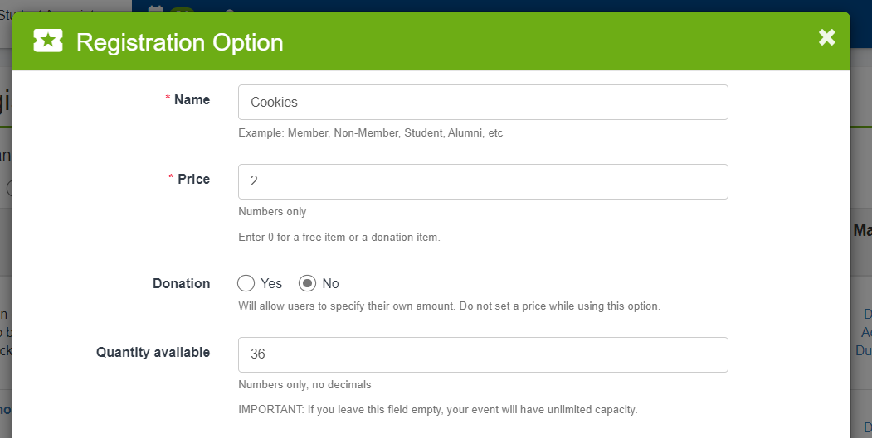
Waiting List – For bake sales or items that have a limited quantity you may not need this feature – more applicable for event tickets or seats on a bus, etc.

Sale parameters:
- Setting minimum and maximum sales can be useful if you have limited quantities or want folks to buy a minimum amount
- Each item can have its own sales date range – or you can leave that blank and use the event opening and closing dates so that all items are the same, but keep in mind that in order to fall under the “occasional Sales rule” you need to have less than 20 days of sales per year.
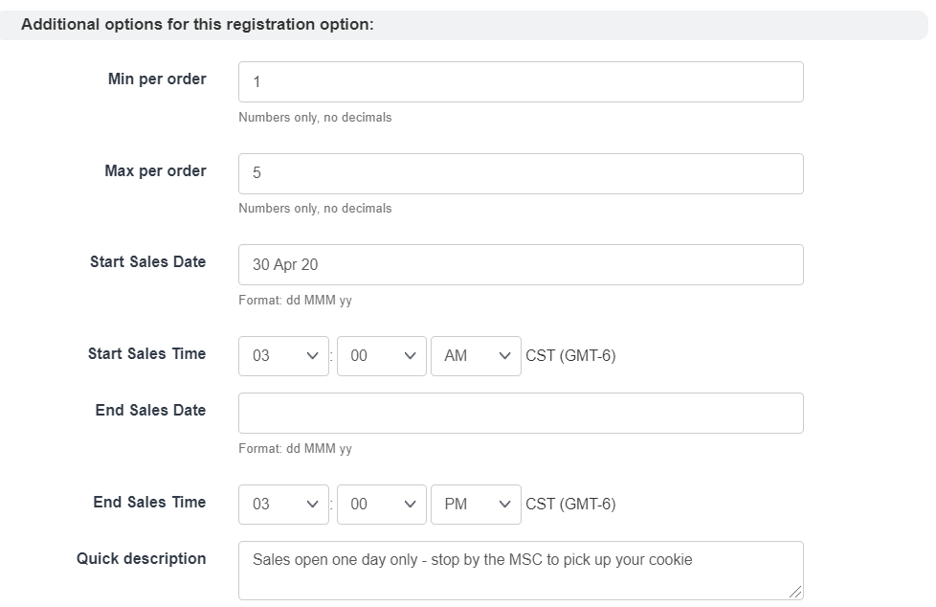
- This is where you would put the entire sales date and time opening – use this if all items will be available at the same time – or open sale early to allow for pre-sales with pick up available on a certain day.
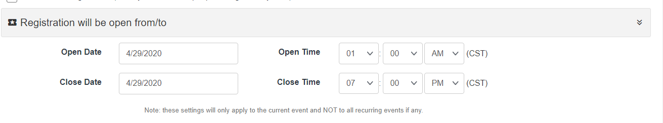
- Putting a description listed above in the photo by item b. in this space shows up right next to the item name.
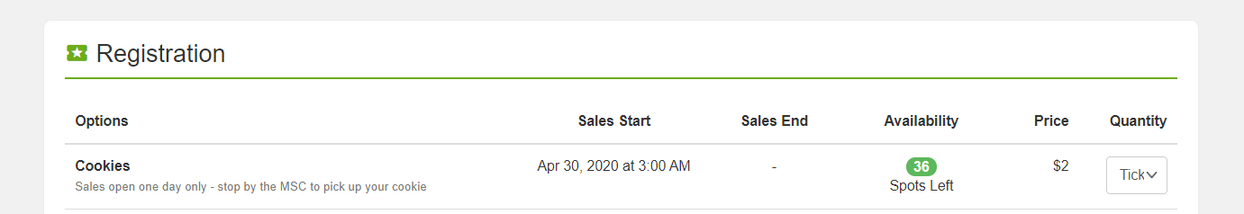
- Who has purchased your items will show up in the event attendance section for the event:
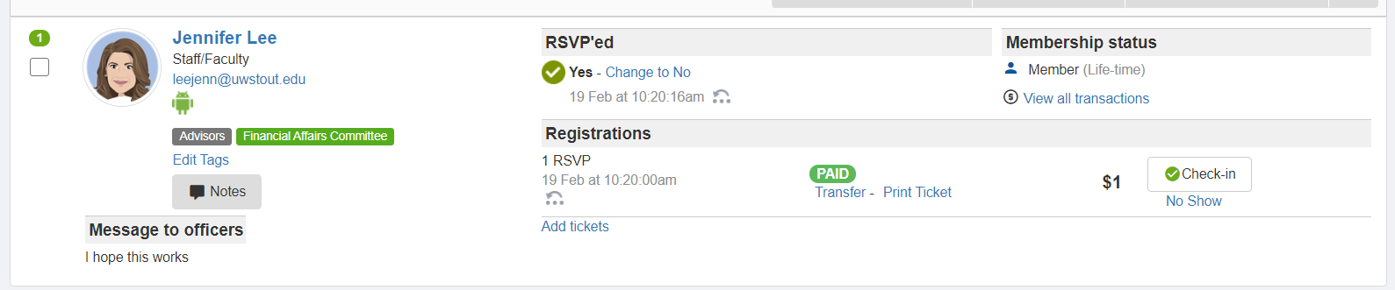
AND all sales will show up here under online revenues where you can generate various reports:
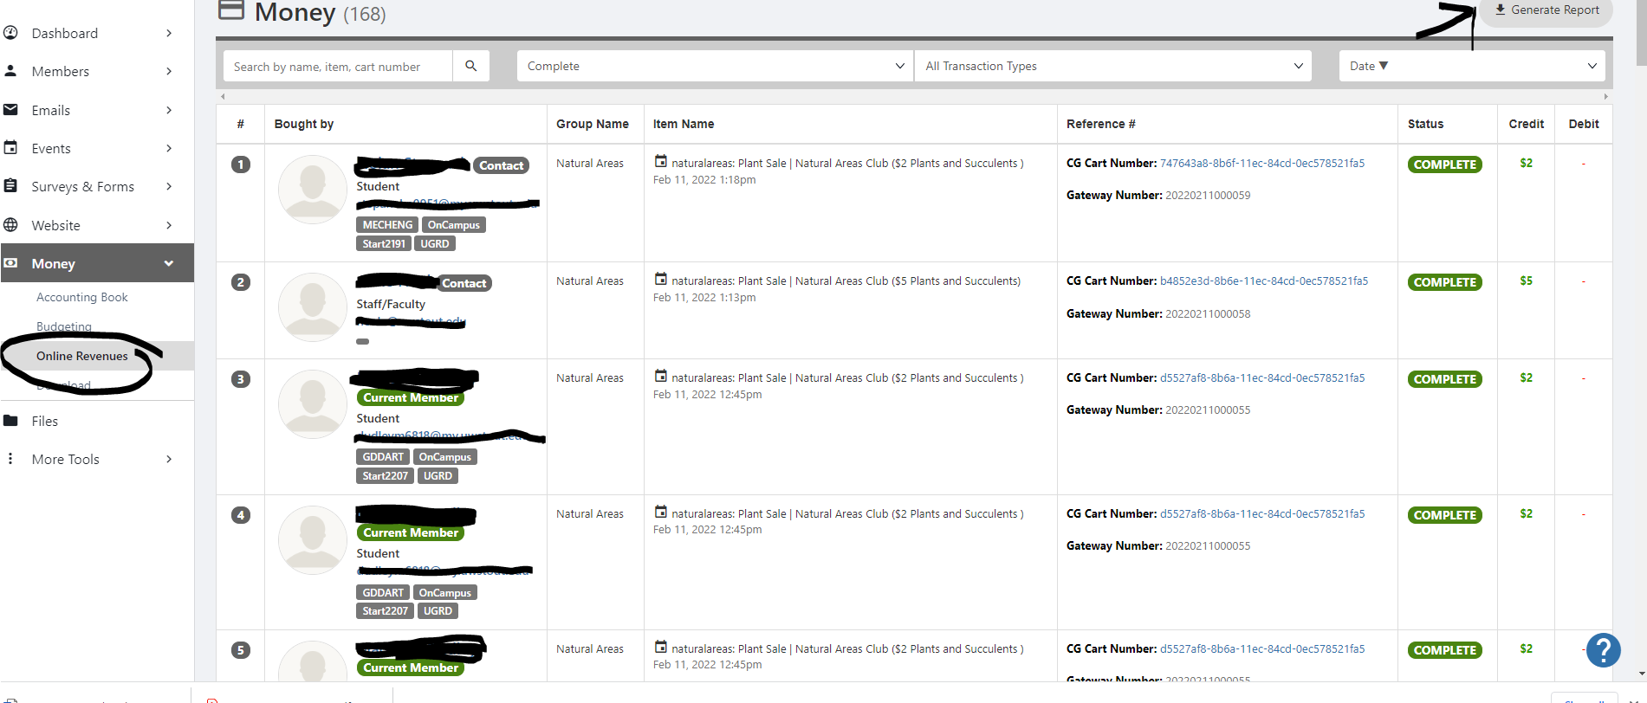

- If you are selling items such as raffle tickets – all raffle ticket guidelines also apply (See SSA website for Raffle License information).

Event Ticket example:
- Create an event like you would any other.
  - It is important to remember that if you’ve received any funding from SSA and are charging UW-Stout students for the event you must first pay back SSA (per UW-System Policy Paper 820).
  - If you are charging non-UW-Stout students to cover a specific expense and only that expense (i.e. meals at a conference you may do that so UW-Stout seg fees are not supporting non-Stout students, but may only charge for the meal portion that will be paid to University Catering). If you are charging non-UW-Stout students for an event provided free to UW-Stout students (other than just covering meals), you must pay SSA back for those users if SSA funded.
- You can create different types of tickets (i.e. student, non-student), however the system only allows for reserved seating if you set your tickets for specific seats. We recommend you reserve seats for sign language interpreters if you want to have the event be accessible.
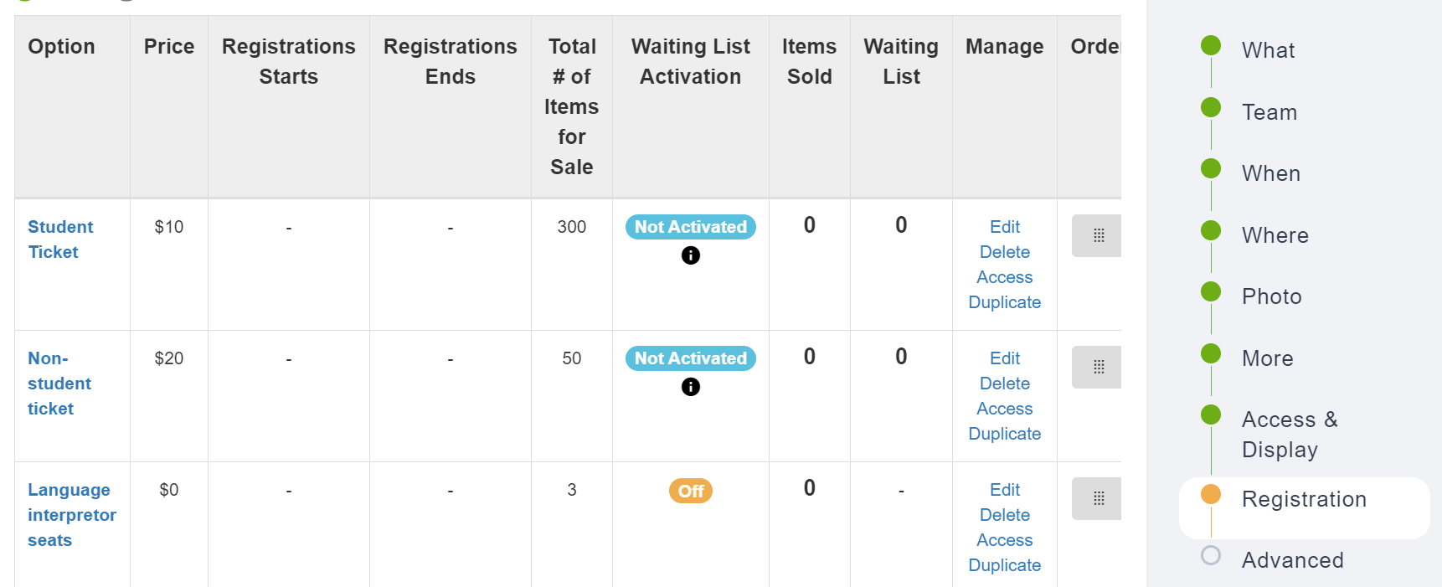
- Make sure to set limits to the capacity that your venue allows (i.e. seats on a bus, seats per table, limited student or non-student tickets, etc.)
- All other steps are like merchandise sales.

Section 3 – Accessing online sales funds.
- Your funds will be deposited into your Agency Account – they will likely be available to spend within a few business days.
- Follow agency account procedures to withdraw funds.
- Please plan for a 3% fee to be charged on transactions when SSA runs out of money dedicated to this endeavor. Likely this will not be necessary through 2023, but pay attention to the LOOP.
- If you sell items that require sales tax you are responsible for paying that and pricing accordingly.

Section 4 – Fees for online sales
- Transaction fees are charged differently by each credit card. Please estimate a 3% fee when pricing your items. Currently fees are charged at the end of the month, so it is important to not spend all your profits and not plan for this expense.
- At this time SSA will be covering fees that do not exceed $30/semester. In the future we will likely be charging individual organizations for their fees.

Section 5 – Sales Tax Guidance:
The excepts below from the Sate of Wisconsin – Department of Revenue – Sales Tax Exemptions for Nonprofit Organizations guide (publication 206) should help organizations get started on determining when and if they should be charging sales tax. Please consult full publication if you have additional questions.

What is a nonprofit organization?
  - A nonprofit organization includes a neighborhood association, church, civic group, garden club, social club, or similar organization not organized for profit where no part of the net earnings inures to the benefit of any private shareholder or individual.

What is subject to tax:
  - Sales, licenses, leases, and rentals of tangible personal property, certain coins and stamps, certain leased property affixed to realty, and certain digital goods are subject to the Wisconsin state sales tax. Certain services (e.g., parking, certain lodging, and admissions to amusement, athletic, entertainment, or recreational events) are also subject to sales tax.
Standards for the occasional sale exemption (examples applicable to student organizations are noted in full publication linked above):
All the three standards listed below must be met by a nonprofit organization for its sales to qualify as exempt occasional sales:
  - Standard 1: The organization is not engaged in a “trade or business.”
    - Currently this means less that sales occur on fewer than 20 days per calendar year and less than $25,000 in receipts.
  - Standard 2: Entertainment is not involved at an event for which charges by the organization constitute admission.
    - For this purpose, “entertainment” means entertainment provided at an “admission” event by all persons or groups (e.g., band or singers) who are paid in the aggregate more than $10,000 per event by all persons for performing, for reimbursement of expenses, or prize money
  - Standard 3: The organization does not have and is not required to have a seller’s permit.
    - A nonprofit organization is not required to hold a seller’s permit if its sales are exempt from sales and use tax (i.e., it meets Standards 1 and 2).
If you have additional questions email: Involvement@uwstout.edu to be directed to the appropriate person on campus to assist. Depending on the nature of your question it might be referred to one or more of the following:
- The Financial Affairs Committee Advisor, Jennifer Lee, leejenn@uwstout.edu
- The Director of the Financial Affairs Committee, Maya Van Hemert, ssafinancialaffairs@uwstout.edu
- The Student Orgs Accounts manager, Rhonda Rubenzer, rubenzerr@uwstout.edu

