Food from Sams club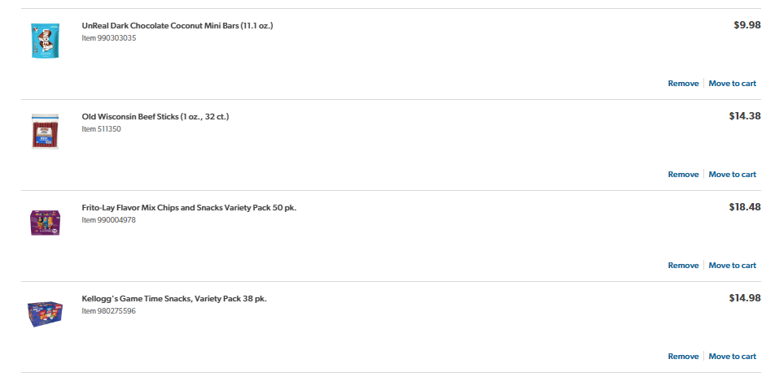

Amazon purchases for Prize

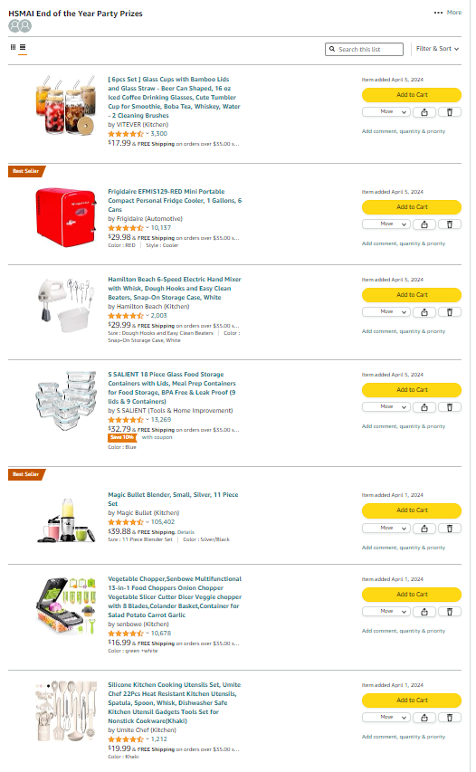

Amazon Purchases for decorations

