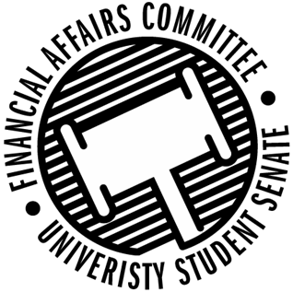

# Meeting Agenda

4:30 PM White Pine Room, Memorial Student Center

50th Congress March 9th, 2020

1. Call to Order
2. Roll Call

|  |  |  |  |
| --- | --- | --- | --- |
|  | Present | Absent | Excused |
| Director Gentz |  |  |  |
| Vice Chair Halbach |  |  |  |
| Senator Dumke |  |  |  |
| Senator Kleinschmidt |  |  |  |
| Senator Korte |  |  |  |
| Senator Reindl |  |  |  |
| Advisor Lee |  |  |  |

1. Approval of the Agenda
2. Approval of the Minutes
   1. 3-2-2020
3. Words of Wisdom
   1. Senator Halbach
4. Unfinished Business
5. New Business
   1. Annual Budget Appeal Hearings – 10 minutes each
      1. 4:40 pm – Fishing Club
      2. 4:50pm – Stout Typographical Society
   2. Rollover Request
      1. BDP – Funding for additional prizes for Homecoming bingo
      2. BDP – Funding to bring additional people on the NACA Conference
      3. Stoutonia – Funding for a camera and hardware
      4. Stoutonia – Funding for ID badges
      5. SSA – Funding for food for the Election Watch Party
      6. SSA – Funding for 4 years’ worth of Sam E. Wood Medallions
   3. Reallocation Requests
      1. Natural Areas Club
      2. HSSO
      3. Men’s Rugby
   4. Contingency 3 Deliberations
6. Announcements
7. Adjourn