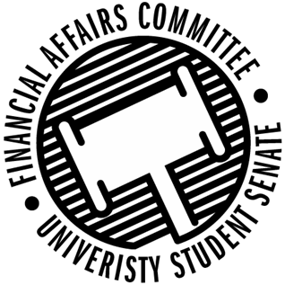

Meeting Agenda
4:00 PM White Pine Room, Memorial Student Center
50th Congress February 12th, 2020
- Call to Order
- Roll Call
 | Present | Absent | Excused
Director Gentz
Vice Chair Halbach
Vice President Johnson
Senator Dumke
Senator Kleinschmidt
Senator Korte
Senator Reindl
Advisor Rubenzer
Advisor Lee

- Approval of the Agenda
- Words of Wisdom
- Unfinished Business
  - Annual Budget Deliberations
  - Reallocations
- New Business
- Announcements
- Adjourn

