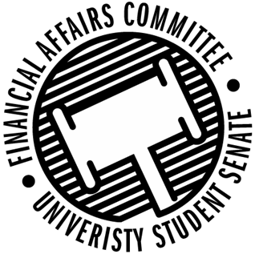

Meeting Agenda
3:30 PM White Pine Room, Memorial Student Center
50th Congress December 13th, 2019
- Call to Order
- Roll Call
 | Present | Absent | Excused
Director Gentz
Vice Chair Halbach
Vice President Johnson
Senator Dumke
Senator Kleinschmidt
Senator Korte
Senator Penoske |  |  | X
Senator Reindl
Advisor Lee

- Words of Wisdom
  - Senator Penoske
- Approval of the Minutes
  - 12-6-19
- Approval of the Agenda
- Unfinished Business
- New Business
  - Rollover Requests
    - SSA
  - Reallocation Request
    - Wrestling Club
  - New Member Training
  - Sport Clubs Commission Update
- Announcements
- Adjourn

