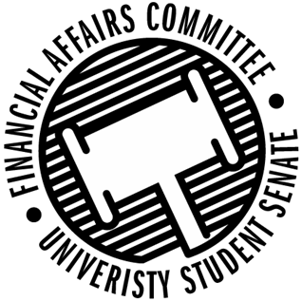

Meeting Agenda
3:30 PM White Pine Room, Memorial Student Center
50th Congress October 11th, 2019
- Call to Order
- Roll Call
April 12, 2019 | Present | Absent | Excused
Director Gentz
Vice Chair Halbach
Senator Hilbert
Senator Dumke
Senator Penoske
Advisor Lee

- Words of Wisdom
  - Senator Penoske
- Approval of the Minutes
  - 10-4-19
- Unfinished Business
  - Contingency I Rules
- New Business
  - Contingency I Hearings
    - 3:45 – WITS
    - 3:50 – Blue Devil Boxing
    - 3:55 – Blue Devil Lifting / APICS
    - 4:00 – Cycling Club
    - 4:05 – Fishing Club
    - 4:10 – PONG
    - 4:15 – HSMAI
    - 4:20 – IREM
    - 4:25 – Wrestling Club
    - 4:30 – Women’s Hockey
    - 4:35 – ASME
    - 4:40 – Waterski
    - 5:00 – Fine Arts Association
    - 5:10 - ASBMB
- Announcements
- Adjourn

