Title: Organization Approval – Eta Sigma Delta, The International Hospitality Management Honor Society

Whereas, Eta Sigma Delta, The International Hospitality Management Honor Society has petitioned to the Stout Student Association Organizational Affairs Committee to become a Recognized Student Organization;

Whereas, Eta Sigma Delta, The International Hospitality Management Honor Society has completed all necessary tasks to become a Recognized Student Organization;

Whereas, the purpose of Eta Sigma Delta, The International Hospitality Management Honor Society is to “recognizes the scholastic and professional achievements of students and alumni from institutions granting diplomas, associate and baccalaureate degrees, graduate degrees, or their equivalents, in the field of hospitality, tourism, and culinary arts.”;

Whereas, Eta Sigma Delta, The International Hospitality Management Honor Society will present an opportunity for students at UW-Stout with a place to recognize achievements in hospitality and to grow their professional opportunities in the field;

Be it therefore resolved, we, the U.S.S. of the S.S.A. approve the Eta Sigma Delta, The International Hospitality Management Honor Society as a Recognized Student Organization for the remainder of the 2019-2020 academic year.

Date acted upon: March 3, 2020

Action: PASSED

Vote: 18 - 0 - 0 (Yays-Nays-Abstentions)

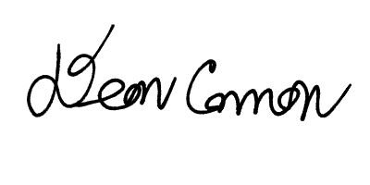

______________________ ______________________
Deon Canon
President
Stout Student Association
Christopher Johnson
Vice-President
Stout Student Association

