Meeting Minutes
Gender and Sexuality Alliance
General Meeting
Wednesday, Oct 6, 2021 6-7pm
Attendance: 6
- Introductions.
- Debrief on La Espiritista.
- Logo Contest (attachment 1).
  - New branding
  - Large format logo and small format logo/icon.
  - Vote on logo designs Wednesday, November 3rd.
- Library Window Decorating Contest (attachment 2).
  - Em and Kendra volunteered to work on library window decorating contest.
- Budget Deadlines
  - Event ideas shared on Discord and CONNECT forum.
- Organization re-registration vacancies.
  - Filled by Kendra
- Meeting next week: Movie Night!
- End meeting.
- Played Cards Against Humanity

Attachment 1
Current Logo:

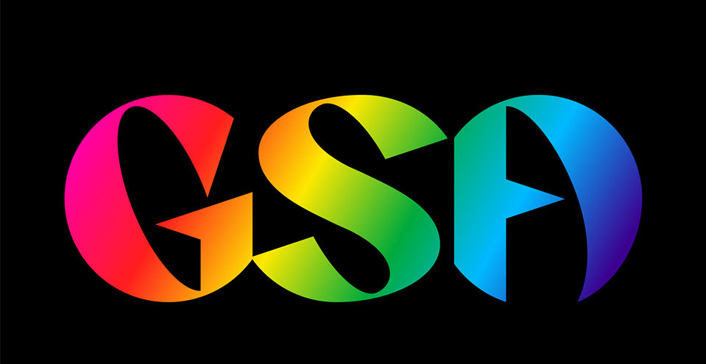

New Logo Rules
- Quality must be high. Vector graphics preferred.
  - Vector graphics - Wikipedia
- Must have a complimentary icon with the Logo or is scalable.

Attachment 2
