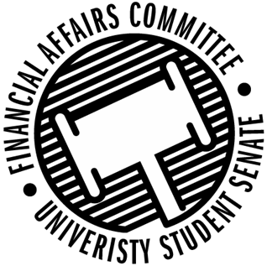

Meeting Agenda
4:30 PM Microsoft Teams Virtual Meeting
50th Congress April 13th, 2020
- Call to Order
  - 4:33 PM
- Roll Call
 | Present | Absent | Excused
Director Gentz | X
Vice Chair Halbach | X
Senator Dumke | X
Senator Kleinschmidt | X
Senator Korte | X
Senator Reindl | X
Advisor Lee |  |  | X

- Approval of the Agenda
  - Approved by unanimous consent
- Approval of the Minutes
  - 3-30-2020
    - Approved by unanimous consent
- Words of Wisdom
  - Senator Dumke
    - “Anytime someone tells me I can’t do something; I want to do it more.” – Taylor Swift
    - Senator Kleinschmidt nominated for next meeting.
- Unfinished Business
- New Business
    - Rollover Reform
      - Discussed proposal for flat number or a percentage cap for rollover.
      - Motion for $30,000 to be the cap for all 3 principal orgs by Dumke, 2nd by Korte.
      - Approved 5-0-0
    - Contingency Changes
      - Turn contingency process into more like the green fee where students can apply for contingency whenever they need to instead of periodically throughout the year.
    - Standing Policy Updates
      - Director Gentz is currently working on re formatting the standing policy and we will discuss more next week.
- Announcements
- Adjourn
  - Adjourned at 5:10 PM

