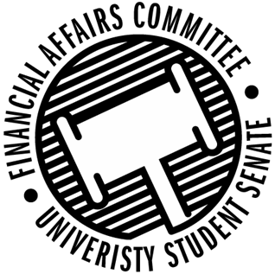

Meeting Agenda
5:00 PM White Pine Room, Memorial Student Center
50th Congress February 3rd, 2020
- Call to Order
- Roll Call
 | Present | Absent | Excused
Director Gentz
Vice Chair Halbach
Vice President Johnson
Senator Dumke
Senator Kleinschmidt
Senator Korte
Senator Reindl
Advisor Rubenzer
Advisor Lee

- Approval of the Minutes
  - 12-13-19
- Approval of the Agenda
- Unfinished Business
- New Business
  - Reallocation Requests
    - IGDA
    - IGDA
    - WITS
    - Ski and Snowboard
    - Stout Students UNITE
  - Annual Budget Hearings (10 min each)
    - 5:15pm - Paintball
    - 5:25pm – Bowling Club
    - 5:35pm – Yeti Ultimate
    - 5:45pm – Women’s Rugby
    - 5:55pm – Food Science Club
    - 6:05pm - IEEE
    - 6:15pm – AFS
    - 6:25pm – Force for Freedom
    - 6:35pm – Tennis Club
    - 6:45pm – Women’s Volleyball
    - 6:55pm – IGDA
    - 7:05pm – Stout Student Affiliates in School Psychology
    - 7:15pm – Veterans Club
    - 7:25pm – WITS
    - 7:35pm - NASO
    - 7:45pm – Ski & Snowboard
    - 7:55pm - HSMAI
    - 8:05pm – Model UN
    - 8:15pm – Slow Food
    - 8:25pm - Prometheus
    - 8:35pm - PCMA
    - 8:45pm – Foundations
    - 8:55pm – Sigma Alpha Epsilon
    - 9:05pm – Psi Chi
    - 9:15pm – Black Student Union
    - 9:25pm – Swim Club
    - 9:35pm – Engineers Without Borders
- Announcements
- Adjourn

