Maya Basics
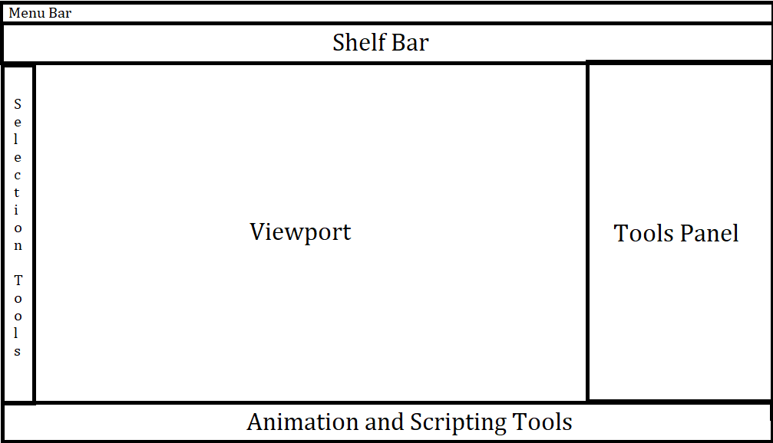
Keys/Buttons | What it does
Left Mouse Button (LMB) | Select the object
Right Mouse Button (RMB) / Hold | Opens radial menu / more options regarding a specific object. Drag mouse to option you want to select then release.
Alt + LMB | Rotate camera around a point
Alt + RMB | Move camera forward and back
Alt + MMB | Pan Camera
Alt + MMB(Scrollwheel) | Zoom in/Out
Ctrl + S | Save
Ctrl + Z | Undo a recent change you’ve made (deletion, moving, properties)
Ctrl + Y | Redo a recent change you’ve made (deletion, moving, properties)
Ctrl + C | Copy an object, properties, or text field
Ctrl + V | Paste an object, property or text field
Ctrl + X | Cuts (used to “move items” without leaving behind a copy) an object, property or text field.
Ctrl + D | Makes a duplicate of an object right on top/inside of it
Select -> Delete | Deletes your selection (if you are certain you don’t want it)
Space Bar | Tap it with mouse in viewport to see 4 different view modes, then hover the view you want and tap it again to select/expand the view
Select -> W | Activates the move tool on the selected object/edge/vertex/face
Select -> E | Activates the rotate tool on the selected object/face/edge/vertex
Select ->R | Activates the scale tool on the selected object/face/edge/vertex
4 | Activates wireframe mode to let you see the vertex/edges
5 | Activate shaded mode to view object with/without lights
6 | Activate texture mode to toggle object’s texture visibility
Select ->F | Automatically focuses selection into view, great with outliner
Select ->A | Automatically focuses all objects on view
Shift + LMB | Select more than one object
Ctrl + LMB | Deselect specific objects
Select -> Edit -> Delete by Type - > History | Deletes the history of changes you have made to the object (such as extruding) without changing
Ctrl + G | Groups the selected objects
Shift + G | Deselects the selected objects
Ctrl + E | Extrudes the selected components of an object. Can also be done via the modeling toolkit or Edit Mesh menu
Menu Bar -> Magnet Symbols | These symbols, when activated, snap the pivot point of your selected component. Ex: Snap to grid snaps to grid, snap to point snaps to vertexes
X + Move | Snaps the component to the grid
D + Move | Moves the pivot point using the move tool
X + D + Move | Snaps the pivot a point on the grid
G + Move | Snaps to curve
Ctrl + H | Hides object
Shift + Ctrl + H | Unhides the object in the outliner
Edit -> Duplicate Special ->Options | Duplicate an object several times with the same transformation
Modify - > Freeze Transformations | Freezes all the transformations you have done to your object, only do it if you are 100% sure you are done with the model. Check with me.
B | Turns on soft selection tool. Selects components within the radius of the tool instead of just one. Good for organics/sculpting. Works best on objects with high subdivisions
B (Hold) + LMB (Move left or right) | This increases/decreases the radius of the soft selection tool

General Tips
- Always rotate around the object to make sure everything is correct
- Inputs section of the Channel box helps manipulate properties of objects
- A collection of modeling modes/tools/selection settings can be found in the modeling toolkit in the tools panel
- File -> Export -> FBX is how to export an object to be ready to imported
- SAVE OFTEN. Maya likes to crash often. Also set up incremental saves.
- Make sure your objects are within scope
- If you’d like to get into animation, look up rigging in Maya and Animation.
- Use the hypershader (blue orb in menu) to add materials/colors to faces which can then be changed within Unreal. This allows you to have one part of the mesh that is glowing, while another part is rock. Materials transfer over to Unreal if option is checked.
- Using curves can decrease the amount of time it takes to create some objects
- Camera based selection controls wether your LMB box selections select components behind what is visible in your viewport
- Change the pivot from World to Local to help with transforming the object. (Modeling toolkit)
- Objects that are HUGE (landmarks) make for really cool supporting meshes in both animation and game development.
- Mesh Tool menu helps with modyfing the whole mesh properties such as adding edge loops/subdivisions
- Edit Mesh Menu has a couple more options than in the modeling toolkit.
- You can make your own custom shelf.
- If you plan to one day use your models commercially, you must have official paid version of Maya. Otherwise you can use the free student version to learn (but not sell). It is the most used professional modeling/animation tool in both the games and movie industry.
- Set a project so you can organize your scene files.

Lynda Tutorial (1-3) (, Understanding 3D, Modeling and 3D Geometry, Patch based Surfaces)
- Normals are the direction a surface is facing, used for lighting
- Primitives are basic shapes you can use to make more complex shapes
- Ways to add detail: Extrude, Bevel, Add Edge Loops, Boolean
- Areas where curvature is tighter, he has more detail: Armpit, Hips, Elbows
- Subdividing means you cut each polygon into 4 times polygons, smooths models out
- Subdiving over a smaller space adds more detail and better/tighter curvature
- Additional detail/Subdivisions are normally placed on places where characters need to bend
- Normals maps can be made with a higher resolution version of a model and its normal and then applied to a lower resolution model
- Nurbs are made with curves using points that define hulls, usually join at one edge
- Bezier patch modeling uses similar curves to that of illustrator
- Revolve/lathe a shape to spin it around an axis to create a surface
- Lofting stretches a surface along several curves, can make several curves to trace the shape of a model
- Extruding using a curve extrudes along the path
- Bunching the poles and bending makes a rectangle/square into a sphere
- You can trim a shape into a nurb using a curve, but it doesn’t actually delete vertexes of the original mesh. Effect sort of looks like a texture with transparent background. All the vertices are still there but aren’t visible. It bends the hulls to give the desired shape.
- You may have to connect several patches together to get the shapes you want
Texture and Materials
- Specularity = highlight of the lights in the room
- Shiny surfaces are smooth, matte surfaces are rough
- Lamberts = matte shader material, only has surface color and shading
- Shiny surfaces you can use phong, blinn, antistrophic. They can also have color and have controls for size and shape of specular highlights.
- Ambient Color affects shading of object, how much ambient light is hitting it
- Diffuse = color or texture layer of a shader
- Specularity adds highlights, give the eye a clue as to how reflective or shiny an object is. The smoother, the shinier. You can change size of highlight and the roll off of the highlight to control how shiny it appears. Color of the highlight.
- Anistropic shader – non circular highlight, you can change the angle of it, the spread, and size of it.
- Bumpy surface with specularity allows us to see the bumpiness of a surface. Without it, it becomes harder to tell the surface quality of something rough.
- Specularity can help us see the curve and shape of objects.
- There exist custom type materials that perform specific functions. Such as a glass material set up to simulate reflections and refractions. Skin shader, car shader.
- You can create custom materials using node editor in Maya.
- You can affect the look of a surface using bump maps without having to add extra detail. Sort of warps light, creates an illusion of roughness. Maintains the sihloutte and polygons. Doesn’t extend to the edges.
- Displacement map changes geometry of the surface. Adds geometry to create the surface. A lot more detail when it renders.
- Normal Mapping lets you have bumpy features of a high rez model onto a low rez model. Uses RGB coordinates of the image to map to xyz on the actual object. Allows you. Gives you the best of both worlds of a bump map and displacement map without the extra detail. Popular effect.
- Fitting a 2d texture to a 3D object is called mapping. Such as the wrapping in the can. Can be mapped in multiple ways Mapping along a flat plane is called planar.
- Mapping in 3D specifies specific parts of an image that correspond to specific faces on a model.
- UV Editing – Mapping a flat 2D image to a 3D Object. Selecting a face of the model will select its corresponding location/face in the UV editor.
- Best way to visualize UV wrapping of a character is to think of him as a stuff animal. Made up of individual pieces (cylinder for arms and legs that are stretched. UV’s have seams to represent connecting edges.

Rendering
- Scanline renderers, fast, can look good but cannot use advanced techniques
- Raycasting uses the camera as a source of rays cast into the scene. Fast real time and used in game engines.
- Raytracing traces rays as they bounce throughout the scene. Allows for more realism and advanced optical effects such as reflections and refractions.
- Radiosity takes raytracing a step farther by allowing objects themselves to become light sources, creating a better simulation of ambient and bounce lighting.
- You can bend laws of physics in 3D such as casting shadows.
- Cameras are virtual so you can control all aspects of image such as focal length, aspect ratio, depth of field, specific object culling.
- Rendering starts by adding lights, then camera, and render.
- Ambient Lighting – general lighting in the room. Can be a light in the scene or software configured thing, or lighting from the room (bounce lighting, or secondary lighting). A general level of light/brightness in the scene. Used to set an overall level of light. Can have a color.
- Point Light shoots light in all directions. Movable, can change color
- Spot light is a directional cone light in a specific direction. Can change cone angle, or create a penumbra(soft edge shadow). Can be moved, rotated.
- Directional Light(Sun) directional light with no area of focus. Its like a spotlight but not limited to an area. Not affected by position.
- Area Light softbox that generates the light from a specific area(ex: square). Sometimes increasing the scale increasing the intensity of the light.
- You can change way shadows look: you can change the color of the shadow(a lighter gray for a not so black shadow)
- Depth map shadows creates shadows by casting a bitmap over the image. Fast. Controlling the resolution of the bitmap allows you to control the quality of the shadow. Lower resolution is more pixelated. You can blur low res shadows to create a soft edge shadow. But to make hard edge you need to increase the resolution. Contigent on the size of the map, the bipmap goes across the entire area the bitmap covers. So if you move it back and make it cover more ground with the same resolution, the shadow quality will decrease, same effect as scaling a mesh which stretches out pixels. Worse with transparency. Worse with self-shadowing. Used more often because they render way faster.
- Raytrace shadows traces the rays of light through the scene to create shadows. Slow. Handles transparency a lot better than depth map shadows. Creates better self-shadowing. Best to only use when you need to handle transparency better.

