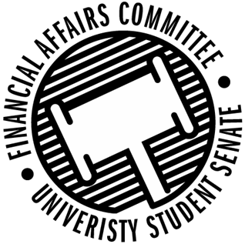

Meeting Agenda
4:30 PM Microsoft Teams Virtual Meeting
50th Congress April 20th, 2020
- Call to Order
- Roll Call
 | Present | Absent | Excused
Director Gentz
Vice Chair Halbach
Senator Dumke
Senator Kleinschmidt
Senator Korte
Senator Reindl
Advisor Lee

- Approval of the Agenda
- Approval of the Minutes
  - 4-13-2020
- Words of Wisdom
  - Senator Kleinschmidt
- Unfinished Business
  - Rollover Reform
  - Contingency Changes
  - Standing Policy Updates
- Announcements
- Adjourn

