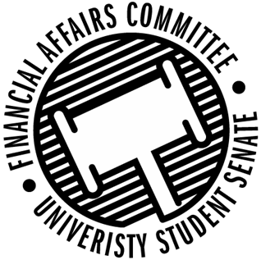

Meeting Agenda
3:30 PM White Pine Room, Memorial Student Center
50th Congress November 15th, 2019
- Call to Order
- Roll Call
 | Present | Absent | Excused
Director Gentz
Vice Chair Halbach
Vice President Johnson
Senator Dumke
Senator Penoske
Senator Reindl
Advisor Lee

- Words of Wisdom
  - Senator Dumke
- Approval of the Minutes
  - 11-15-19
- Approval of the Agenda
- Unfinished Business
  - Meeting time for Spring 2020
- New Business
  - Contingency 2 Hearings
    - 3:45 – Students for Consent
    - 3:50 – Fishing Club
    - 3:55 – Stout Retail Association
    - 4:00 – Her Campus
    - 4:05 – Blue Devil Lifting
    - 4:10 – NASO
    - 4:15 – Stout Student Dietetic Association
    - 4:20 – IEEE
    - 4:25 –
    - 4:30 –
    - 4:35 –
    - 4:40 – SAE Baja
    - 4:45 – Engineers Without Borders
    - 4:50 – Gender and Sexuality Alliance
    - 4:55 –
    - 5:00 – Stout Student Association
  - Reallocation Request
    - Model UN
  - Rollover Request
    - Stout Student Association
    - Blue Devil Productions
- Announcements
- Adjourn

