Title: Organization Approval – Film Society of UW-Stout

Whereas, Film Society of UW-Stout has petitioned to the Stout Student Association Organizational Affairs Committee to become a Recognized Student Organization;

Whereas, Film Society of UW-Stout has completed all necessary tasks to become a Recognized Student Organization;

Whereas, the purpose of Film Society of UW-Stout is “To increase interest and understanding of film in contemporary culture through the use of creative public programing such as a yearlong series of contemporary and/or international motion picture programs and interactive discussion.”;

Whereas, Film Society of UW-Stout will provide the Students with great experience to learn about film and the impact they have on our lives and the study of them;

Be it therefore resolved, we, the U.S.S. of the S.S.A. approve the Film Society as a Recognized Student Organization for the remainder of the 2019-2020 academic year.;

Date acted upon: April 15, 2020

Action: Passed

Vote: 24 - 0 - 0 (Yays-Nays-Abstentions)

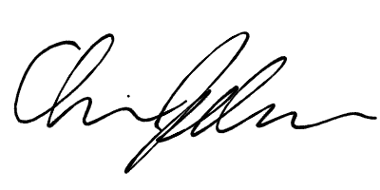
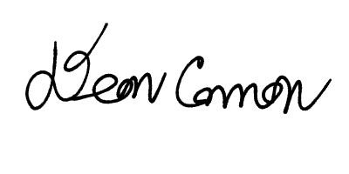

______________________ ______________________
Deon Canon
President
Stout Student Association
Christopher Johnson
Vice-President
Stout Student Association

