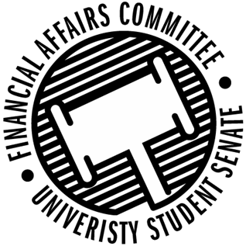

Meeting Agenda
4:30 PM Badger Room, Memorial Student Center
50th Congress February 24th, 2020
- Call to Order
  - 4:32 PM CST
- Roll Call
 | Present | Absent | Excused
Director Gentz | X
Vice Chair Halbach | X
Senator Dumke | X
Senator Kleinschmidt | X
Senator Korte | X
Senator Reindl | X
Advisor Lee | X

- Approval of the Agenda
  - Approved
- Approval of the Minutes
  - 2-3-2020, 2-5-2020, 2-6-2020, 2-7-2020, 2-10-2020, 2-12-2020, 2-13-2020, 2-17-2020
  - Approved
- Words of Wisdom
  - Vice President Johnson
    - “We ought to do good to others as simply as a horse runs, or a bee makes honey, or a vine bears grapes season after season without thinking of the grapes it has borne.” Marcus Aurelius
    - “Look back over the past, with its changing empires that rose and fell, and you can foresee the future, too.” Marcus Aurelius
    - Senator Dumke nominated for next week
- Unfinished Business
- New Business
  - Budget Appeal Hearings (10 minutes each)
    - Sport Clubs Commission – 4:40pm
      - Athletic trainer needed for approximately 56 events for next year, which would be an increase of 20 events up from 36.
      - Number may be closer to $6,720 compared to $10,000
    - WEAR Fashion Association – 4:50pm
      - Confusion came from is the Fashion Show required from academic credit.
      - Students are not required to participate in this event, making it open to everyone on campus.
      - Try to reach out to professionals for Videographer and Photographer, otherwise student connections.
      - Money asked for under rewards was intended for certificates and flowers, looking for plaques possibly.
  - Budget Appeal Deliberations
    - WEAR Fashion
      - Funded $3,000 for ETC and Custodial, $500 each for the photographer and videographer
    - Sport Clubs Commission
      - Approved $6720 needed for the athletic trainer due to it being used for 56 individual events
  - Rollover Request
    - SSA
      - $600 for SSA Election survey from ARC
      - Motion to approve by Halbach, 2nd by Kleinschmidt
      - Approved 5-0-0
    - SSA
      - $150 for Congressional Committee Vice Chair
      - Motion by Kleinschmidt to approve, 2nd by Reindl
      - Approved 3-0-2
  - Reallocation Request
    - Yeti Ultimate
      - Moving from Lodging from Black Penguin to Meltdown tournaments
      - Motion to approve by Dumke, 2nd by Korte
      - Approved 5-0-0
  - Stout Retail Association Lodging Issue
    - Trip to Chicago, need more money but already received funding during contingency.
- Announcements
  - Director Gentz – Shared Governance
- Adjourn
  - Motion to adjourn by Kleinschmidt, 2nd by Korte
  - Approved 3-2-0
  - Division called by Halbach, Gentz defeated Halbach 2 games to 1 in Rock, Paper, Scissors to adjourn.

