Unreal Engine 4 Basics
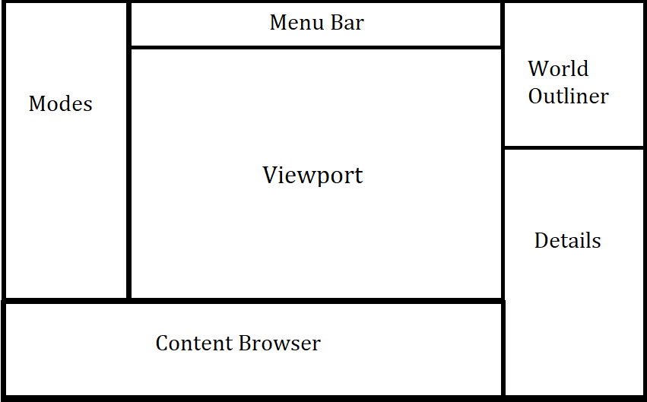
Key/Buttons | What it does
Left Mouse Button CLICK (LMB) | Select object/field over mouse
Right Mouse Button CLICK (RMB) | View additional options of objects over mouse
RMB(Hold) + Drag | Free look within the viewport
RMB(Hold) + WASD | Move in all directions within the viewport (relative to camera face direction)
LMB(Hold) + Drag | Move forward/out in viewport OR drag assets into the level
MMB(Hold) + Drag | Pan the camera
Select -> F | Focuses onto the object in the viewport
Select -> Delete | Deletes the asset from level OR project (be careful if removing from project)
Select -> W | Change to move widget
Select -> E | Change to rotation widget
Select -> R | Change to scaling widget
Ctrl + LMB | Select/Deselect several actors/assets
Ctrl + Alt + LMB Drag | Create a rectangle that selects objects within it (careful as it may select unwanted objects)
Alt + Move/Rotate | Create a duplicate/copy of selected actors
Ctrl + G | Group selected actors
Shift + G | Ungroup selected actors
Alt + G | Perspective view
Alt + J | Top orthographic view
Alt + Shift + J | Bottom orthographic view
Alt + K | Left orthographic view
Alt + Shift + K | Right orthographic view
RMB + Transform + Mirror X/Y/Z | Reflect/flip the asset around a specific axis
RMB on a vertex in orthographic view | Snaps the asset/vertices to the grid
Ctrl + Z | Undo
Ctrl + Y | Redo
Shift + Move | Moves the selected assets along with the camera
Shift + 1/2/3/4/5 | Changes between the different modes from the Modes panel
RMB a vertex in orthographic view | Snaps the vertex/pivot to the grid

General Tips
- Save often, this is a complex engine with higher chances to crash
- SLAM that undo button, its much faster than moving assets back to where you last had them
- Empty rooms are boring, fill it with supporting meshes, rotate, resize, trick the eye into believing its not the same mesh, place it together with different combinations of assets, symmetry is meant to be calming(booooring), asymmetry is chaotic and EPIC
- Always try to have a reference for what you are making, be it from the internet or one of you’re favorite games
- If you persist on only using perspective view, always move the camera around to make sure there are 100% no unwanted gaps. If you want to assure everything is lined up nicely, use orthographic views.
- Look at the other example projects and how they combined assets together to make a scene, what techniques can you “borrow” but still look unique. Unreal is made so it is easy to learn in reverse (seeing what the pros do, then analyzing it one step at a time)
- Use the filters in the content browser to look for things easily
- You have the power to do ANYTHING the pros can do with this engine.
- Be the unique change you want to see in the industry, create with INTENT
- You can view performance information in the drop down menu inside the viewport
- BUILD your project to view your changes
- If you can’t find an object, look in the world outliner!
- Viewport options allow you to toggle/modify snap of (W, E, R) as well as camera speed and Local/World mode which determines wether it’s the axis of the item or world. And what to show in the viewport.

