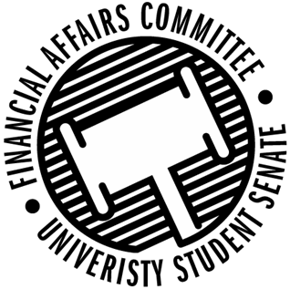

Meeting Agenda
3:30 PM White Pine Room, Memorial Student Center
50th Congress October 18th, 2019
- Call to Order
- Roll Call
April 12, 2019 | Present | Absent | Excused
Director Gentz
Vice Chair Halbach |  |  | X
Senator Dumke
Senator Penoske |  |  | X
Advisor Lee
President Canon
Vice President Johnson

- Words of Wisdom
  - Director Gentz
- Approval of the Minutes
  - 10-11-19
- Unfinished Business
  - Contingency I Rules
- New Business
  - Contingency I Hearings
    - 3:45 – Marketing & Business Education Association
    - 3:50 – Her Campus
    - 3:55 – Industrial Designers Society of America
    - 4:00 -
    - 4:05 – Jujitsu
    - 4:10 – Tabletop Games
    - 4:15 – School Counselling Organization
    - 4:20 – ISP
    - 4:25 – Women’s Rugby
    - 4:30 – Stout Retail Association
    - 4:35 – Stout Model United Nations
    - 4:40 –
  - Contingency I Deliberations
- Announcements
- Adjourn

