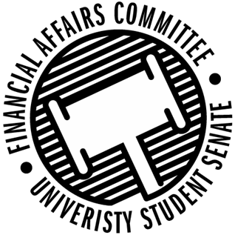

Meeting Agenda
4:30 PM Badger Room, Memorial Student Center
50th Congress February 24th, 2020
- Call to Order
- Roll Call
 | Present | Absent | Excused
Director Gentz
Vice Chair Halbach
Senator Dumke
Senator Kleinschmidt
Senator Korte
Senator Reindl
Advisor Lee

- Approval of the Agenda
- Approval of the Minutes
  - 2-3-2020, 2-5-2020, 2-6-2020, 2-7-2020, 2-10-2020, 2-12-2020, 2-13-2020, 2-17-2020
- Words of Wisdom
  - Director Gentz
- Unfinished Business
- New Business
  - Budget Appeal Hearings (10 minutes each)
    - Sport Clubs Commission – 4:40pm
    - WEAR Fashion Association – 4:50pm
  - Budget Appeal Deliberations
  - Rollover Request
    - SSA
    - SSA
  - Reallocation Request
    - Yeti Ultimate
  - Stout Retail Association Lodging Issue
- Announcements
  - Director Gentz – Shared Governance
- Adjourn

