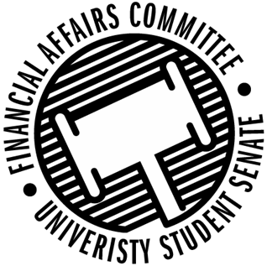

Meeting Agenda
3:30 PM White Pine Room, Memorial Student Center
50th Congress December 6th, 2019
- Call to Order
- Roll Call
 | Present | Absent | Excused
Director Gentz
Vice Chair Halbach
Vice President Johnson
Senator Dumke
Senator Penoske
Senator Reindl
Advisor Lee

- Words of Wisdom
  - Senator Dumke
- Approval of the Minutes
  - 11-22-19
- Approval of the Agenda
- Unfinished Business
  - Reallocation Request
    - Model UN
  - Meeting time for Spring 2020
- New Business
  - Reallocation Request
    - SSA
  - Contingency 2 Deliberations
- Announcements
- Adjourn

