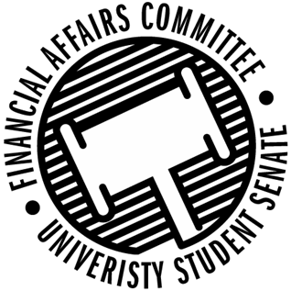

Meeting Agenda
3:30 PM White Pine Room, Memorial Student Center
50th Congress November 15th, 2019
- Call to Order
- Roll Call
 | Present | Absent | Excused
Director Gentz
Vice Chair Halbach |  |  | X
Vice President Johnson
Senator Dumke
Senator Penoske
Advisor Lee

- Words of Wisdom
  - Director Gentz
- Approval of the Minutes
  - 11-8-19
- Approval of the Agenda
- Unfinished Business
  - Meeting time for Spring 2020
- New Business
  - Contingency 2 Hearings
    - 3:45 – Men’s Volleyball
    - 3:50 – Yeti Ultimate
    - 3:55 – School Counseling Organization
    - 4:00 – PONG
    - 4:05 – WITS
    - 4:10 – Packaging Association of Stout
    - 4:15 – Stout Student Dietetic Association
    - 4:20 – Women’s Rugby
    - 4:25 – Black Student Union
    - 4:30 – Sports Clubs Commission
    - 4:35 – Clay Target Shooting Club
    - 4:40 –
    - 4:45 –
    - 4:50 –
    - 4:55 –
    - 5:00 – WEAR Fashion Association
    - 5:05 – Tea Time Animation
    - 5:10 – AnBu
  - Reallocation Request
    - Her Campus
- Announcements
  - Director Gentz – Sports Clubs Meeting, Budget Workshop
- Adjourn

