Request Payment Instructions:
Each student needs to submit their own request; you cannot submit this asking for reimbursement for someone other than yourself

- Go to your Organizations portal.
- In the left navigation, click on “Money”, then “Budgeting”.
- Scroll to find the appropriate event you are requesting payment/reimbursement/purchasing for. Then in the category you wish to spend in click “Request Payment”.
2.
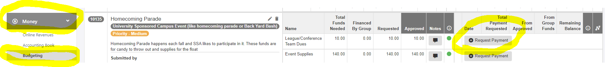
3.
- The next screen you see will look like this:
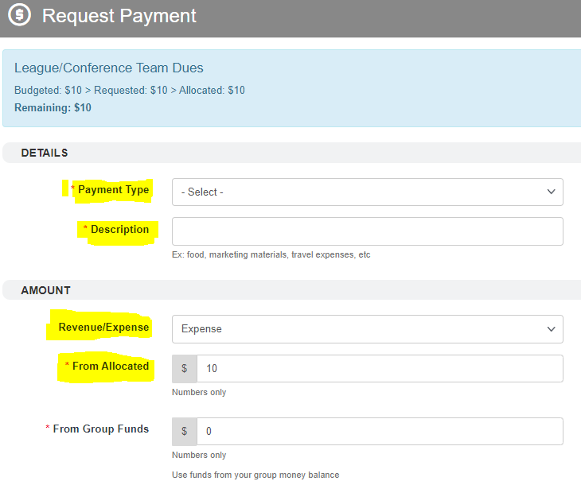
6.
5.
Always use “from allocated” – these are the SSA approved seg fee allocations.
5.
6.
- IMPORTANT! When completing the form, ALWAYS use “From Allocated” – these are your SSA approved allocations. The amount listed is your current balance. Replace this with the ACTUAL amount you are requesting. This cannot be a guestimate and must match the receipt, etc. DO NOT INCLUDE TAX!
- DO NOT USE GROUP FUNDS – this function does nothing at this time and causes reconciliation errors.

