Title: Organization Approval – Menom-Bomb Climbing Club

Whereas, Menom-Bomb Climbing Club has petitioned to the Stout Student Association Organizational Affairs Committee to become a Recognized Student Organization;

Whereas, Menom-Bomb Climbing Club has completed all necessary tasks to become a Recognized Student Organization;

Whereas, the purpose of Menom-Bomb Climbing Club “spread the joys of climbing as well as allow climbers to pass on their knowledge to both those who are new and experienced.”;

Whereas, Menom-Bomb Climbing Club will provide Students with a great opportunity to get out and climbing in a constructive environment;

Be it therefore resolved, we, the U.S.S. of the S.S.A. approved Menom-Bomb Climbing Club as a Recognized Student Organization for the remainder of the 2019-2020 academic year.

Date acted upon: April 21, 2020

Action: PASSED

Vote: 22 - 0 - 0 (Yays-Nays-Abstentions)

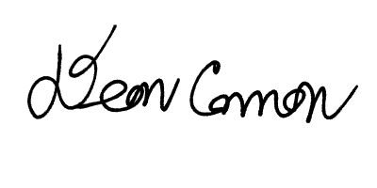

______________________ ______________________
Deon Canon
President
Stout Student Association
Christopher Johnson
Vice-President
Stout Student Association

