Title: Adjournment Sine Die of the 50th Congress

Whereas, the 2019-20 academic year is coming to an end;

Whereas, the 51st Congress election results have been approved;

Whereas, the 50th Congress of the Stout Student Association has no further unfinished business to attend to;

Be it therefore resolved, we, the 50th Congress of the Stout Student Association adjourn sine die.

Date acted upon: April 29, 2020

Action: Passed

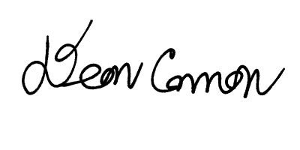
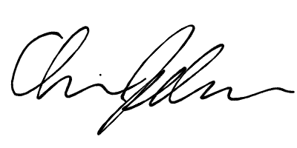
Vote: 26 - 0 - 1 (Yays-Nays-Abstentions)

______________________ ______________________
Deon Canon
President
Stout Student Association
Christopher Johnson
Vice-President
Stout Student Association

