Agenda
Gender and Sexuality Alliance
General Meeting
Wednesday, Oct 6, 2021 6-7pm
- Introductions.
- Debrief on La Espiritista.
- Logo Contest (attachment 1).
  - New branding
  - Large format logo and small format logo/icon.
  - Vote on logo designs Wednesday, November 3rd.
- Library Window Decorating Contest (attachment 2).
  - Pizza party for first place
  - Most votes/scariest: custom vinyl banner.
  - More details in the Oct 6, 2021, “The Loop” email.
- Budget Deadlines
  - 2021-2022 budget timeline.
  - Opens November 15.
  - Closes January 31.
  - Funding for events and club activities next year.
  - Need to form an event planning group.
- Organization re-registration vacancies. Seeking stand-ins (no commitment) for official organization status (recognition and funds from SSA).
  - Treasurer
  - Vice President
- Meeting next week: Movie Night!
  - Will vote on one out of 4-5 titles.
  - Bring yourselves, snacks, and friends.
  - Location: MSC likely (room TBD)
- End meeting.

Attachment 1
Current Logo:

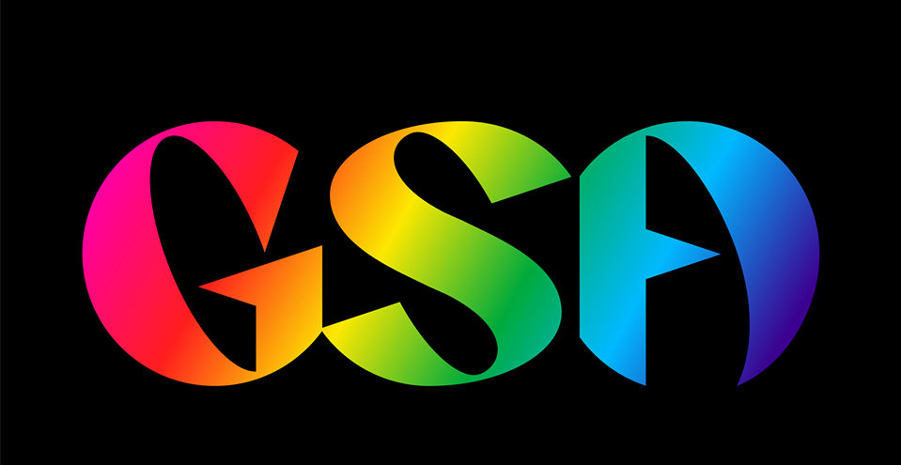

New Logo Rules
- Quality must be high. Vector graphics preferred.
  - Vector graphics - Wikipedia
- Must have a complimentary icon with the Logo or is scalable.

Attachment 2
