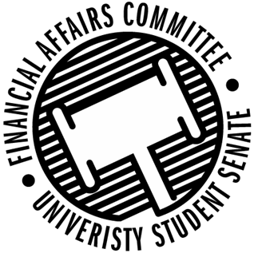

Meeting Agenda
4:30 PM White Pine Room, Memorial Student Center
50th Congress February 17th, 2020
- Call to Order
- Roll Call
 | Present | Absent | Excused
Director Gentz
Vice Chair Halbach
Vice President Johnson
Senator Dumke
Senator Kleinschmidt
Senator Korte
Senator Reindl
Advisor Rubenzer
Advisor Lee

- Approval of the Agenda
- Words of Wisdom
- Unfinished Business
  - Reallocations
    - WITS
    - Ski and Snowboard
    - SSU
    - Fishing Club
- New Business
  - Reallocations
    - Men’s Soccer
    - Cycling Club
- Announcements
- Adjourn

