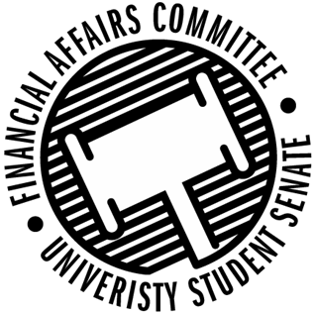

Meeting Agenda
4:00 PM White Pine Room, Memorial Student Center
50th Congress February 5th, 2020
- Call to Order
- Roll Call
 | Present | Absent | Excused
Director Gentz
Vice Chair Halbach
Vice President Johnson
Senator Dumke
Senator Kleinschmidt
Senator Korte
Senator Reindl
Advisor Rubenzer
Advisor Lee

- Words of Wisdom
  - Advisor Rubenzer
- Approval of the Agenda
- Unfinished Business
- New Business
  - Annual Budget Hearings (10 min each)
    - 4:10pm – Clay Target Shooting Club
    - 4:20pm – Sport Clubs Commission
    - 4:30pm – HSMAI
    - 4:40pm – Pepper Magazine
    - 4:50pm – Natural Areas Club
    - 5:00pm – Blue Devil Productions
    - 5:20pm – Taekwondo Club
    - 5:30pm – Comic Creators
    - 5:40pm – Waterski Team
    - 5:50pm – Men’s Club Soccer
    - 6:00pm – Antique Auto Club
    - 6:10pm – GreenSense
    - 6:20pm – Tea Time Animation
    - 6:30pm – International Club
    - 6:40pm – Ducks Unlimited
    - 7:00pm – SSDA
    - 7:20pm – Packaging Association
    - 7:30pm – Running Club
    - 8:20pm – MBEA
    - 8:30pm – Stout Student Association
- Announcements
- Adjourn

