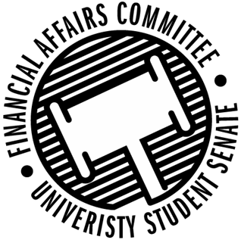

Meeting Agenda
3:30 PM White Pine Room, Memorial Student Center
50th Congress September 20th, 2019
- Call to Order
  - 3:32 PM
- Roll Call
April 12, 2019 | Present | Absent | Excused
Director Gentz | X
Senator Dumke | X
Senator Halbach | X
Senator Penoske | X
Advisor Lee | X

- Words of Wisdom
  - Director Gentz
  - “Don’t Trust the State” – Gary Ramos
  - Senator Dumke Next Week
- Open Forum
  - Training
    - Viewpoint Neutrality
    - Policy Paper 820
- Approval of the Minutes
  - 4-12-19
  - Approved
- Unfinished Business
- New Business
  - Vice Chair Election Information
    - Email Director Gentz if interested
  - Reallocation Request
    - Fishing Club
      - Ask for further information on first request
      - Motion to Approve by Dumke, Penoske 2nd
        - Approved 2-0-1
    - Men’s Soccer
      - Motion to Approve by Halbach, Dumke 2nd
        - Approved 3-0-0
    - Sports Clubs Commission
      - Motion to Approve contingent on having 3 or more people going to stay under the registration cap by Halbach, Penoske 2nd
        - Approved 3-0-0
    - International Game Developers Association
      - Motion to Approve by Dumke, Halbach 2nd
        - Approved 3-0-0
    - Institute of Real Estate Management
      - Motion to Deny and Apply in Contingency by Halbach, Dumke 2nd
        - Approved to Deny 3-0-0
  - Contingency I
    - Requests opened last night
    - October 11th Deadline
- Announcements
  - PONG LAN this weekend
- Adjourn
  - Moved by Dumke, Penoske 2nd
  - Adjourned at 4:20 PM CDT

