Title: Organization Approval – ASL (American Sign Language) Club

Whereas, ASL Club has petitioned to the Stout Student Association Organizational Affairs Committee to become a Recognized Student Organization;

Whereas, ASL Club has completed all necessary tasks to become a Recognized Student Organization;

Whereas, the purpose of ASL “is to promote the study of American Sign Language and the appreciation and understanding of Deaf culture by organizing educational and cultural activities open to all interested members of the University and local community.”;

Whereas, ASL Club will provide the Students place to be in an inclusive environment where everyone can come together and organize educational and cultural activities;

Be it therefore resolved, we, the U.S.S. of the S.S.A. approved ASL Club as a Recognized Student Organization for the remainder of the 2019-2020 academic year.

Date acted upon: April 21, 2020

Action: PASSED

Vote: 22 - 0 - 0 (Yays-Nays-Abstentions)

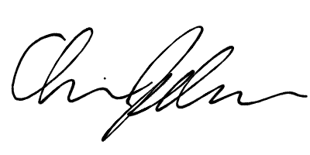
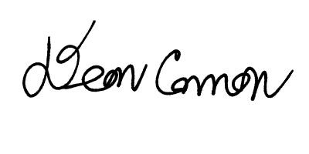

______________________ ______________________
Deon Canon
President
Stout Student Association
Christopher Johnson
Vice-President
Stout Student Association

