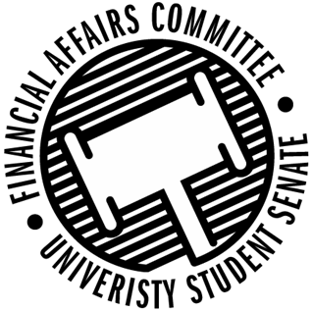

Meeting Agenda
3:30 PM White Pine Room, Memorial Student Center
50th Congress November 1st, 2019
- Call to Order
- Roll Call
April 12, 2019 | Present | Absent | Excused
Director Gentz
Vice Chair Halbach
Senator Dumke
Senator Penoske
Advisor Lee

- Words of Wisdom
  - Senator Penoske
- Approval of the Minutes
  - 10-25-19
- Approval of the Agenda
- Unfinished Business
  - Contingency 1 Budget
- New Business
  - Just-In-Time Request
    - Engineers Without Borders
  - Rollover Cap Discussion (Time Permitting)
- Announcements
- Adjourn

