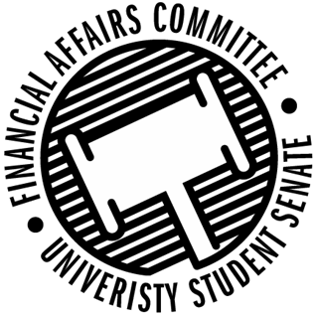

Meeting Agenda
3:30 PM Walnut Room, Memorial Student Center
50th Congress October 4th, 2019
- Call to Order
- Roll Call
April 12, 2019 | Present | Absent | Excused
Director Gentz
Vice Chair Halbach
Senator Dumke
Senator Penoske
Advisor Lee

- Words of Wisdom
  - Senator Penoske
- Approval of the Minutes
  - 9-27-19
- Unfinished Business
  - Reallocation Requests
    - NASO
      - “We would prefer to have multiple events throughout the month, but it's my understanding that we could not do that when it comes to reallocating funds. So we are planning to have a one day event, potentially on November 4th.”
    - Stout Pre-Health Society
- New Business
  - Reallocation Requests
    - Yeti Ultimate
    - APICS
  - Contingency I Rules
- Announcements
- Adjourn

