Requesting funding from Stout Student Association (SSA)
Things you want to consider prior to beginning your funding request:
- What events does your organization want to do during that funding period?
- Each event will need a separate funding request – this is a little bit different than our previous system where you asked for all events within one request.
- What are the things that you will need for each event – make sure that you are spending some time working with your group members on what supplies you might need for the event.
The 3 steps that must be completed for all budget requests from SSA:
- Fill out a request in CONNECT prior to the deadline (Steps 1-6 below)
- Sign up for a budget hearing in CONNECT (Step 7 below)
- Attend budget hearing to present your budget and answer FAC questions. Your representative gets only 10 minutes for presentation and questions so they should focus on the budget request event details rather than the functions of the group which cannot be considered in this process.

Step 1 in making a request - Login
- Login to CONNECT at connect.uwstout.edu or from the logins page
- Use your UW-Stout credentials

Step 2 – Locate the student organization that will be requesting funds
- Find Your Group under “My Groups”

Step 3 – Locate the money tab in the gray task bar on your group page
- Only officers can view the gray task bar.
- If you are not an officer any officer of the group can make you an officer. Once you are an officer the gray task bar will be present for you
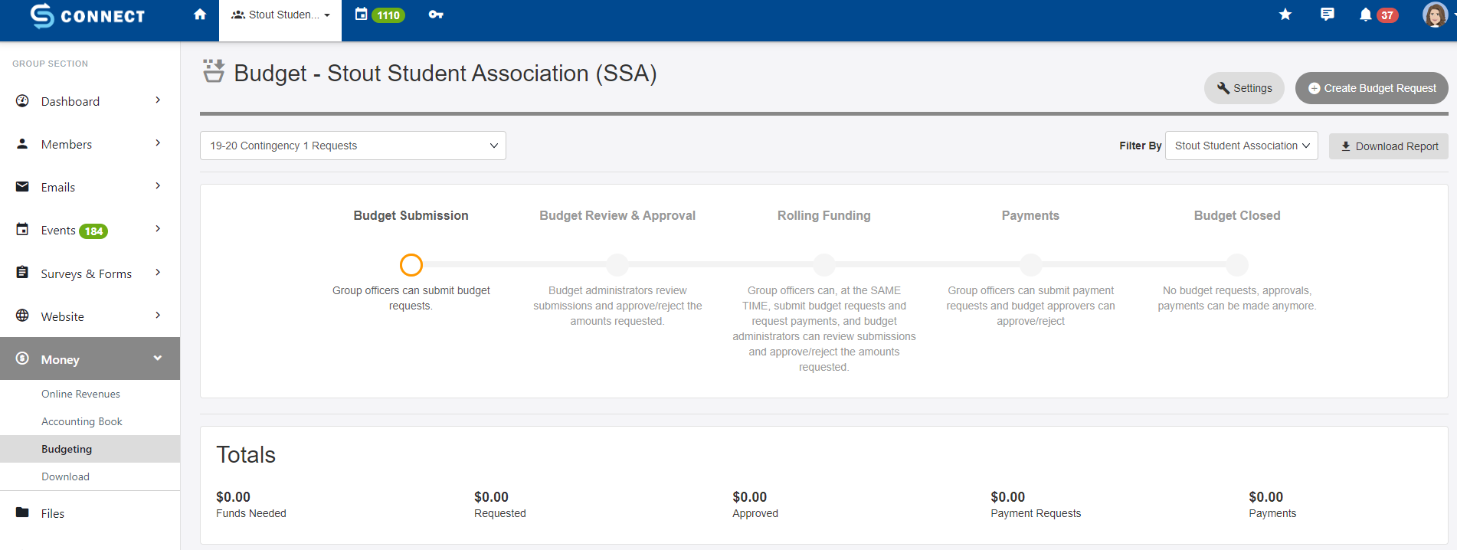
Step 5
Step 3
Step 4

Step 4 – Select the budget period you want to request funds in
- Typically, only one request period will be open, but you will want to make sure your events fall within that budget request timeline

Step 5 – Select Create A Budget Request
- You will need to create a budget request for each event separately. So, if your organization does 5 events you will submit 5 separate requests, one for each event. For events that are a collection of events (i.e. ____________ week, etc.) do a separate request for each event within the event so that the committee can fund like events alike.

Step 6 – Input the event details
- You may not know all the event details at the time, but do your best to estimate the date, time, and location. Keep in mind that this request does not automatically create the event in your student org page – so having limited details will not make your page look like you have incomplete event details. This will be viewable only by the officers in the Money Module.

- You will need to make sure to select the correct EVENT TYPE – certain items can only be requested in certain event type. (i.e. – food is only eligible in certain event types). Selecting items that are not eligible will result in items not being funded if the wrong event categories are selected.

- ONLY ONE EVENT PER REQUEST – so if for example you are having a “Veteran’s issues week” that has 5 different events you will need to submit 5 requests that all have their unique event types

Event Types
Use on-campus event types for most events. If you want an off-campus event to be funded you must request it as a travel event. For a full list of budget rules and event type descriptions see the FAC standing policies, Policy 820 and other documents in the Stout Student Association FAC files.

On campus event types and available categories
For an event to be funded it must ONLY use the budget item categories available as listed below.
- Competition - event services (i.e. Referee, custodial, etc.), event supplies, or conference dues/league dues
- Educational/Instructional - event supplies, event services, speaker/instructor, advertising, film/movie, food in support of educational or cultural focused event
- Entertainment (Comedian, band, etc.) - advertising, event supplies, event services (tech services, custodial, service fees, etc.), contracted entertainment (speaker, band, comedian, magician, etc.), film/movie, food in support of educational or cultural focused event
- Meeting - this is for members only and can only have event supplies if it is advertised to the whole campus at least two weeks in advance
- Practice - event supplies, facility use (use only for facilities located near campus that are not provided on campus like ice rink, swimming pool, bowling alley, etc. - anything outside the Menomonie area is a trip).
- Recruitment - (for Backyard bash or involvement fair use university sponsored event type instead) advertising, event supplies, promotional items, food for recruitment
- Group Development - event supplies, event services (for anything off campus use trip social/recreational
- University Sponsored Campus event - (i.e. Backyard Bash, Homecoming parade, etc.) event supplies

On or Off Campus:
- Sales/Fundraising event - any items purchased in this kind of event are loan only and should be listed under event supplies

Travel/trips Off Campus
Any event held off campus is considered a trip. All trips must be open and available to everyone and advertised according to the budget rules. Please use the appropriate trip category and only available categories.
- Travel- group professional - trip to conferences, meetings, tours related to field, etc. - vehicle rental (bus, auto, van, etc.), Mileage or Gasoline, Registration/event fee/tickets, airfare, lodging
- Travel - social/recreational - travel for the purpose of fun/recreation - vehicle rental (bus, auto, van, etc.), Mileage or Gasoline, Registration/event fee/tickets, airfare, lodging
- Travel - competition - travel for the purpose of competing - - vehicle rental (bus, auto, van, etc.), Mileage or Gasoline, Registration/event fee/tickets, airfare, lodging
- Travel- student organization leader - travel for the purpose of bringing back information to better operate your student organization - - vehicle rental (bus, auto, van, etc.), Mileage or Gasoline, Registration/event fee/tickets, airfare, lodging

Event types not eligible for funding:
Varsity Athletics, Campus Program/Department Sponsored, & Service
- Ask for all the separate items you will need for the event. If your screen is too small you may need to TAB at the end to get an “add item” button.

Event details:
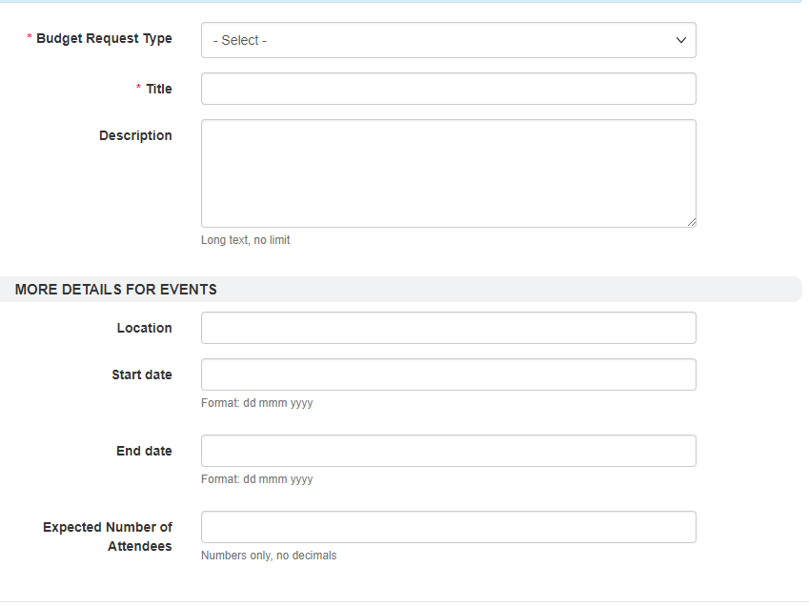
Select correct event type
Title: Be as specific as possible regarding the event for example if you are having a speaker for heart health awareness and you don’t yet know the name of the speaker you could put something like “heart health awareness month speaker”
Description: Do your best to outline what will take place at the event or the goals of the event
Location: Best as specific as possible (i.e. – MSC Great Hall, MSC South Lawn, Indianapolis, IN, etc.)

Start Date: Date your event begins – if you do not know exactly choose a date in the month you intend to do the event – DO NOT LEAVE BLANK
End Date: For many event types this will be the same as the start date and could be left blank, but if you are traveling this would be the return date – it may be a guess
Expected number of attendees: Give your best guess as to how many students you expect to attend
Example of an event type: Travel Competition
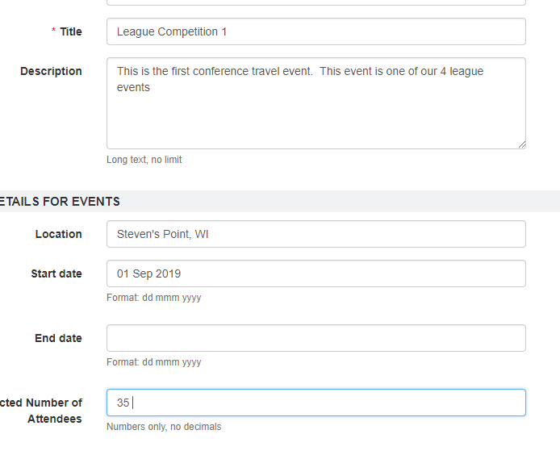

Budget Item Types:
Only Here!!!
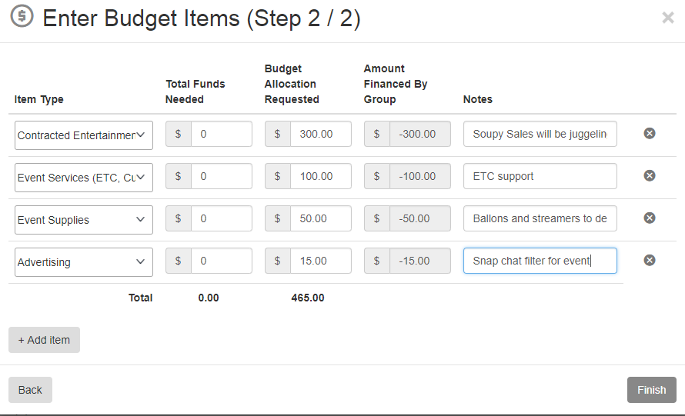
NO _ DO NOT UESE THIS COLUMN

The above example is for and event type: ENTERTAINMENT things it does well:
- Separates out each item into its own type
- Remembers that it needs event services in addition to its contract
Only Here!!!
- Only used the budget allocation requested column
- Describes in detail what each item type will cover
Example of a Travel - competition
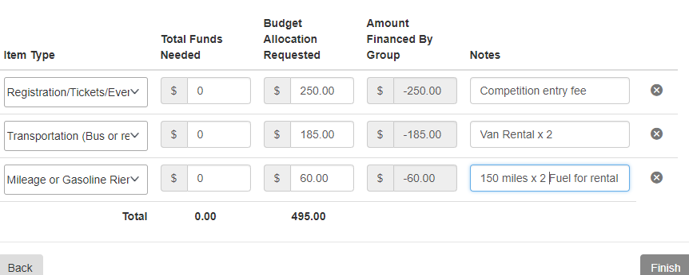
NO - DO NOT UESE THIS COLUMN

What this example does well is:
- Separates each item
- Describes each item specifically
- Indicates how it came to the estimate

This is what a completed event request looks like as it awaits a decision.
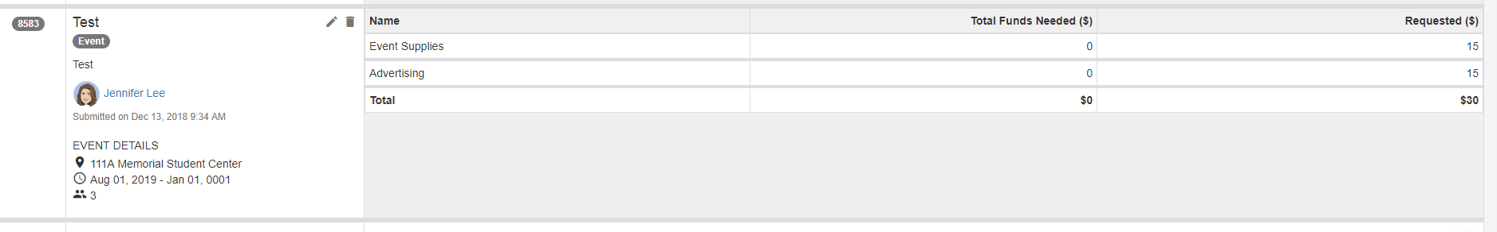

Step 7: Where to sign up for a budget request hearing
- Go to the SSA Page
- Select the Events section
- Click the Budget request hearing for the appropriate budget process
- Register
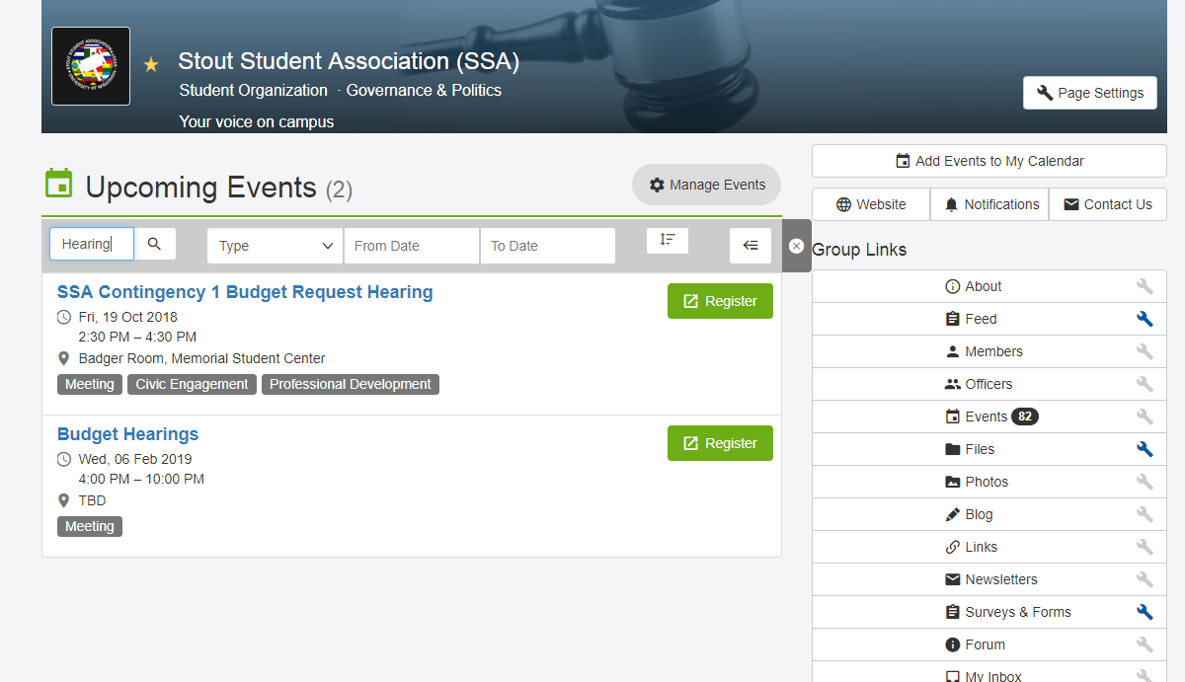
- Choose a time slot, leave a message with the org you are signing up for, and confirm
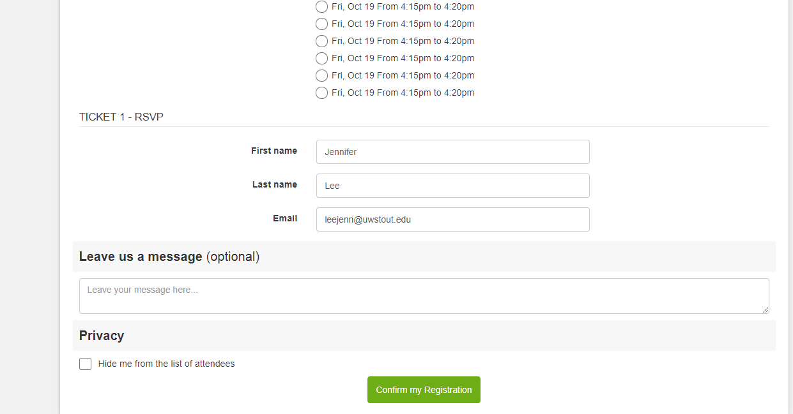
Make sure you include the org name here!!!

Where to find FAC documents in the SSA page:
- Go the SSA page
- Select files
- Select Financial Affairs Documents: FAC Standing Policies, Budget timeline, and PP820
