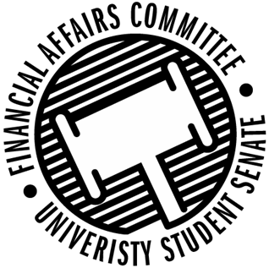

Meeting Agenda
3:30 PM White Pine Room, Memorial Student Center
50th Congress October 11th, 2019
- Call to Order
  - 3:37 PM
- Roll Call
April 12, 2019 | Present | Absent | Excused
Director Gentz | X
Vice Chair Halbach | X
Senator Dumke | X
Senator Penoske | X
Advisor Lee | X

- Words of Wisdom
  - Senator Penoske
    - Sometimes life is about risking life for a dream only you can see. – Senator Penoske
    - Director Gentz Nominated
- Approval of the Minutes
  - 10-4-19
  - Approved
- Unfinished Business
  - Contingency I Rules
    - Postponed
- New Business
  - Contingency I Hearings
    - 3:45 – WITS
      - Present
    - 3:50 – Blue Devil Boxing
      - Present
    - 3:55 – Blue Devil Lifting / APICS
      - Present
    - 4:00 – Cycling Club
      - Present
    - 4:05 – Fishing Club
      - Present
    - 4:10 – PONG
      - Present
    - 4:15 – HSMAI
      - No Show
    - 4:20 – IREM
      - Present
    - 4:25 – Wrestling Club
      - Present
    - 4:30 – Women’s Hockey
      - Present
    - 4:35 – ASME
      - Present
    - 4:40 – Waterski
      - Present
    - 4:45 - Yeti Ultimate
      - Present
    - 4:50 – Competitive Gamers of Stout
      - Present
    - 4:55 – SAE Baja
      - Present
    - 5:00 – Fine Arts Association
      - Present
    - 5:10 – ASBMB
      - Present
  - Reallocations
    - Yeti Ultimate
      - Reallocating from one event to another
        - Move to Approve by Halbach, 2nd Dumke
        - Approved 3-0-0
    - Hooplah Zine Club
      - Reallocating from one issue printing to another
        - Move to approve by Dumke, 2nd by Penoske
        - Approved 3-0-0
- Announcements
- Adjourn
  - Move to Adjourn by Dumke, 2nd Penoske
  - Adjourned at 5:31 PM

