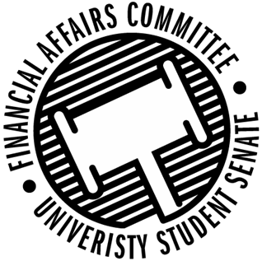

Meeting Agenda
4:00 PM White Pine Room, Memorial Student Center
50th Congress February 12th, 2020
- Call to Order
  - 4:04 PM CST
- Roll Call
 | Present | Absent | Excused
Director Gentz | X
Vice Chair Halbach | X
Vice President Johnson | X
Senator Dumke | X
Senator Kleinschmidt | X
Senator Korte | X
Senator Reindl | X
Advisor Rubenzer | X
Advisor Lee | X

- Approval of the Agenda
  - Approved
- Words of Wisdom
  - Senator Korte
    - What gets measured gets done. -anonymous
    - Vice President Johnson next meeting
- Unfinished Business
  - Annual Budget Deliberations
    - Fishing Club
      - Denied Boat Oil due to it not being owned by the university
      - Denied Tire Jack, Tire Iron, and Trailer Hitch locks because they would be used for personal property not funded by the university
      - Denied practices, due to not being able to fund social/recreational trips over breaks.
      - Approved 528.36 for truck gas for FLW Qualifier because we could not fund more for the boat.
      - Approved up to cap for BASS qualifier gas
      - Denied BASS State Qualifier for Minnesota due to meeting the caps.
    - Food Science Club
      - Approved up to the maximum amount of IFT Tours per the rules
    - Foundations
      - Denied Cabin Rental because we cannot play a non-business entity for lodging
      - Denied Discs because the equipment needs to meet the mission of the org.
    - Gender Sexuality Alliance
      - Funded up to cap for professional speaker
      - Funded up to cap for professional speaker for DICE Conference
      - Funded up to cap for professional speaker for Inclusivity summit
      - Approved Drag Shows as a fundraiser up to the fundraiser cap.
    - Green sense
      - Funded up to the cap for backyard bash
      - Funded up to cap for honorarium
      - Denied Tote Bags due to personal gain/already met group promo cap
    - Hand Drumming Club
      - Approved up to cap for professional contracted entertainment.
    - Hmong Stout Student Organization
      - Funded on $221.65 for appetizers and snacks, cannot fund full meals.
      - Funded up to cap for advertising
      - Denied Hmong Awareness Month Advertising due to hitting the cap
      - Denied Advertising for Hmong New Year due to hitting the cap
      - Denied Volleyball Tournament within Hmong New Year event, due to org charging for admission
      - Funded up to cap for Hmong New Year event
      - Funded up to cap for honorarium for DJ
      - Funded up to cap for professional speaker
      - Denied advertising for speaker series due to previously hitting cap
      - Funded up to cap for DICE Conference Speaker
    - HSMAI
      - Denied Airfare because we do not fund airfare during the annual budget process
    - IEEE
      - Funded up to the cap for workshops, asked as only 1 workshop.
      - Funded reasonable amount for trip to Minneapolis due to lack of details given
    - IREM
      - Denied Global Summit event because it is in Canada, we cannot fund any international travel.
    - International Club
      - Funded up to cap for honorarium, gave amount as one event.

  - Reallocations
- New Business
- Announcements
- Adjourn
  - Motion to adjourn by Dumke, 2nd by Reindl
  - Approved 6-0-0

