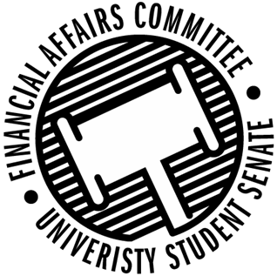

Meeting Agenda
3:00 PM White Pine Room, Memorial Student Center
50th Congress February 7th, 2020
- Call to Order
- Roll Call
 | Present | Absent | Excused
Director Gentz
Vice Chair Halbach
Vice President Johnson
Senator Dumke
Senator Kleinschmidt
Senator Korte
Senator Reindl
Advisor Rubenzer
Advisor Lee

- Approval of the Minutes
- Approval of the Agenda
- Unfinished Business
- New Business
  - Annual Budget Hearings (10 min each)
    - 3:10pm – Latinos Unidos
    - 3:20pm –
    - 3:30pm – Stout Typographical Society
    - 3:40pm – Hand Drumming Club
    - 3:50pm – Colleges Against Cancer
    - 4:00pm – IREM
    - 4:10pm – Disc Golf Club
    - 4:20pm – ISP
    - 4:30pm – Fine Arts Association
    - 4:40pm – Swing Club
    - 4:50pm – GSA
    - 5:00pm – Cru
    - 5:10pm – PONG
    - 5:20pm – Tabletop Gaming
    - 5:30pm – Stoutonia
    - 5:40pm – Society of Plastics Engineers
    - 5:50pm – An-Bu
    - 6:00pm – HSSO
  - Reallocation Request
    - Fishing Club
  - Annual Budget Rules
- Announcements
- Adjourn

