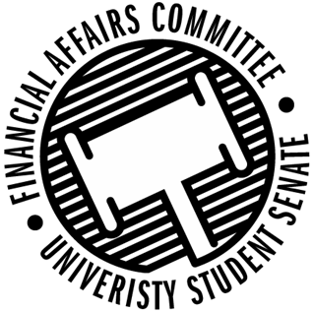

Meeting Agenda
3:30 PM Involvement Center 107, Memorial Student Center
50th Congress September 27th, 2019
- Call to Order
- Roll Call
April 12, 2019 | Present | Absent | Excused
Director Gentz
Senator Dumke
Senator Halbach
Senator Penoske
Advisor Lee

- Words of Wisdom
  - Senator Dumke
- Approval of the Minutes
  - 9-20-19
- Unfinished Business
  - Vice Chair
  - Fishing Club Reallocation
    - “We went on the trip to the B.A.S.S. State Qualifier on the Madison Chain. We didn’t use all the funds from that event and are looking to move the remaining funds to the Fall Bass Bash.”
- New Business
  - Reallocation Requests
    - NASO
    - Clay Target Shooting Club
  - Just In Time Request
    - Water Ski Team
      - “We went to conference this past weekend and competed and got 6th place, top 8 qualify for regionals.”
  - Rollover Reform
  - Contingency I Rules
- Announcements
- Adjourn

