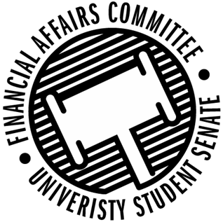

Meeting Agenda
3:00 PM White Pine Room, Memorial Student Center
50th Congress February 7th, 2020
- Call to Order
  - 3:03 PM CST
- Roll Call
 | Present | Absent | Excused
Director Gentz | X
Vice Chair Halbach | X
Vice President Johnson |  |  | X
Senator Dumke | X
Senator Kleinschmidt | X
Senator Korte | X
Senator Reindl |  |  | X
Advisor Rubenzer | X
Advisor Lee | X

- Approval of the Minutes
- Approval of the Agenda
- Words of Wisdom
  - Senator Kleinschmidt
    - Don’t feel bad for making decisions that upset other people, you’re not responsible for their happiness you’re responsible for yours.
    - Senator Reindl Next Meeting
- Unfinished Business
- New Business
  - Annual Budget Hearings (10 min each)
    - 3:10pm – Latinos Unidos
      - Present
    - 3:30pm – Stout Typographical Society
      - Present
    - 3:40pm – Hand Drumming Club
      - Present
    - 3:50pm – Colleges Against Cancer
      - Present
    - 4:00pm – IREM
      - Present
    - 4:10pm – Disc Golf Club
      - Present
    - 4:20pm – ISP
      - Present
    - 4:30pm – Fine Arts Association
      - Present
    - 4:40pm – Swing Club
      - Present
    - 4:50pm – GSA
      - Present
    - 5:00pm – Cru
      - Present
    - 5:10pm – PONG
      - Present
    - 5:20pm – Tabletop Gaming
      - Present
    - 5:30pm – Stoutonia
      - Present
    - 5:40pm – Society of Plastics Engineers
      - Present
    - 5:50pm – An-Bu
      - Present
    - 6:00pm – HSSO
  - Motion to fund none of the annual budget process by Dumke, 2nd by Halbach
    - Motion denied 0-3-1
  - Reallocation Request
    - Fishing Club
      - Moving $167.50 from equipment to bulk fishing line
      - Motion to postpone for further information by Dumke, 2nd by Kleinschmidt
      - Approved 3-0-1
  - Annual Budget Rules
- Announcements
- Adjourn

