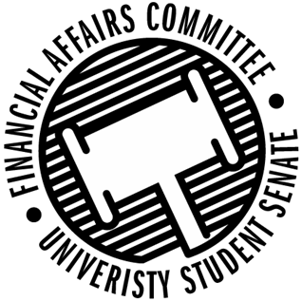

Meeting Agenda
3:30 PM White Pine Room, Memorial Student Center
50th Congress November 8th, 2019
- Call to Order
- Roll Call
April 12, 2019 | Present | Absent | Excused
Director Gentz
Vice Chair Halbach
Senator Dumke
Senator Penoske |  |  | X
Advisor Lee

- Words of Wisdom
  - Senator ?
- Approval of the Minutes
  - 11-1-19
- Approval of the Agenda
- Unfinished Business
- New Business
  - Reallocation Request
    - Force For Freedom
  - Rollover Discussion
  - Sports Club Commission complaint
  - Meeting time for Spring 2020
- Announcements
- Adjourn

