Title: Organization Approval – Men’s Hockey Club at UW-Stout

Whereas, Men’s Hockey Club at UW-Stout has petitioned to the Stout Student Association Organizational Affairs Committee to become a Recognized Student Organization;

Whereas, Men’s Hockey Club at UW-Stout has completed all necessary tasks to become a Recognized Student Organization;

Whereas, the purpose of Men’s Hockey Club at UW-Stout “to provide opportunities to everyone to play the sport of ice hockey. We will strive to provide a fast-paced competitive environment that will have the opportunity to play against the other teams in the UW system, as well as other club hockey teams from around the Midwest.”;

Whereas, Men’s Hockey Club at UW-Stout will provide the Students a great place to continue to play Hockey as they are in college;

Be it therefore resolved, we, the U.S.S. of the S.S.A. approved Men’s Hockey Club at UW-Stout as a Recognized Student Organization for the remainder of the 2019-2020 academic year.

Date acted upon: April 21, 2020

Action: PASSED

Vote: 22 - 0 - 0 (Yays-Nays-Abstentions)

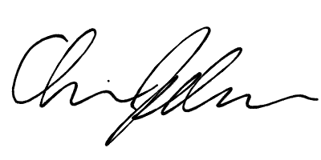
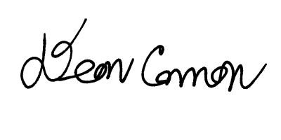

______________________ ______________________
Deon Canon
President
Stout Student Association
Christopher Johnson
Vice-President
Stout Student Association

