Title: Appointment of Senator of the College of Science, Technology, Engineering, Mathematics & Management

Whereas, John-Paul Penoske has taken all the necessary steps to apply for this position and is qualified to serve in this position;

Whereas, John-Paul Penoske has been properly vetted by the Executive Branch and is qualified to serve in this position;

Be it therefore resolved, we, the U.S.S. of the S.S.A. approve that John-Paul Penoske be appointed to serve as the Senator of College of Science, Technology, Engineering, Mathematics & Management of the University Student Senate of the Stout Student Association for the duration of the school year.

Date acted upon: 9/10/2019

Action: PASSED

Vote: 18_0_0

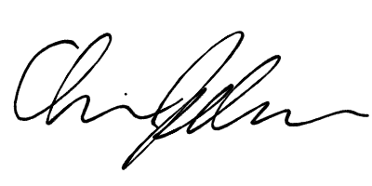
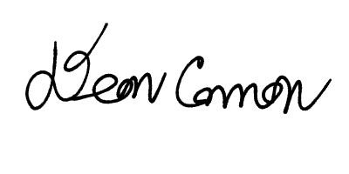

______________________ ______________________
Deon Canon
President
Stout Student Association
Christopher Johnson
Vice-President
Stout Student Association

