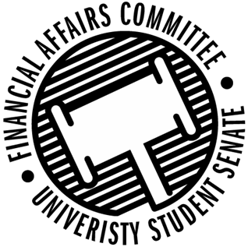

Meeting Agenda
3:30 PM White Pine Room, Memorial Student Center
50th Congress October 18th, 2019
- Call to Order
- Roll Call
April 12, 2019 | Present | Absent | Excused
Director Gentz
Vice Chair Halbach
Senator Dumke
Senator Penoske
Advisor Lee

- Words of Wisdom
  - Senator Dumke
- Approval of the Minutes
  - 10-18-19
- Unfinished Business
  - Contingency I Rules
- New Business
  - Reallocation Requests
    - ISP
    - Society of Manufacturing Engineers
  - Contingency I Deliberations
- Announcements
- Adjourn

