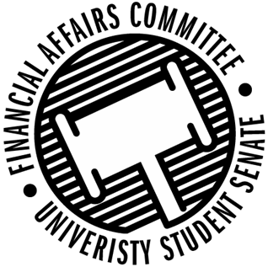

Meeting Agenda
3:30 PM White Pine Room, Memorial Student Center
50th Congress October 18th, 2019
- Call to Order
  - 3:37 PM
- Roll Call
April 12, 2019 | Present | Absent | Excused
Director Gentz | X
Vice Chair Halbach |  |  | X
Senator Dumke | X
Senator Penoske |  |  | X
Advisor Lee | X
President Canon | X
Vice President Johnson | X
Director Kangas | X

- Words of Wisdom
  - Director Gentz
    - “You must have confidence in your competence” – Elijah Cummings
    - Nominated Dumke
- Approval of the Minutes
  - 10-11-19
    - Approved 3-0
- Unfinished Business
  - Contingency I Rules
    - Move to Postpone by Dumke, Seconded by Vice President Johnson
      - Approved 4-0
- New Business
  - Contingency I Hearings
    - 3:45 – Marketing & Business Education Association
      - Present
    - 3:50 – Her Campus
      - Present
    - 3:55 – Industrial Designers Society of America
      - Present
    - 4:05 – Jujitsu
      - Present
    - 4:10 – Tabletop Games
      - Present
    - 4:15 – School Counselling Organization
      - Present
    - 4:20 – ISP
      - Present
    - 4:25 – Women’s Rugby
      - Present
    - 4:30 – Stout Retail Association
      - Not Present
    - 4:35 – Model UN
      - Present
  - Contingency I Deliberations
- Announcements
- Adjourn
  - Moved by Director Kangas, Seconded by Vice President Johnson
    - Approved 2-1-1
    - Adjourned @ 4:56 PM

