Title: Updating the Green Fee Policy

Whereas, the Green Fee Policy needs to be updated;

Whereas, the Green Fee Policy is a living document and should reflect modern standards and modern practices for Green Fee allocations;

Whereas, the Sustainability Council has discussed and passed these changes;

Be it therefore resolved, we, the U.S.S. of the S.S.A. approve the Green Fee Policy edits brought forth by the Sustainability Council.

Date acted upon: April 29, 2020

Action: Passed,

Vote: 27 - 0 - 0 (Yays-Nays-Abstentions)

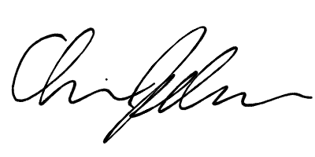

______________________ ______________________
Deon Canon
President
Stout Student Association
Christopher Johnson
Vice-President
Stout Student Association

