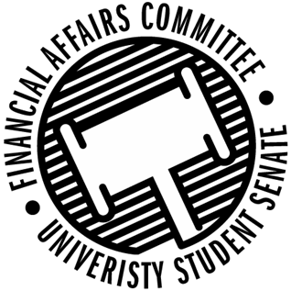

Meeting Agenda
4:00 PM White Pine Room, Memorial Student Center
50th Congress February 6th, 2020
- Call to Order
- Roll Call
 | Present | Absent | Excused
Director Gentz
Vice Chair Halbach
Vice President Johnson
Senator Dumke
Senator Kleinschmidt
Senator Korte
Senator Reindl
Advisor Rubenzer
Advisor Lee

- Approval of the Minutes
- Approval of the Agenda
- Unfinished Business
- New Business
  - Annual Budget Hearings (10 min each)
    - 4:10pm – Cycling Club
    - 4:20pm – Hooplah Zine
    - 4:30pm – Men’s Volleyball
    - 4:40pm – Women’s Club Hockey
    - 4:50pm – WEAR Fashion Association
    - 5:00pm – Stout Students Unite
    - 5:10pm – Blue Devil Lifting, APICS
    - 5:20pm – Council of Supply Chain Management Professionals
    - 5:30pm – AITP
    - 5:40pm – Psychology Club
    - 5:50pm – Society of Manufacturing Engineers
    - 6:00pm – Forward Magazine
    - 6:10pm – Stout Retail Association
    - 6:20pm – Fishing Club
    - 6:30pm – ASBMB
    - 6:40pm – AFS
    - 6:50pm – Blue Devil Smash
    - 7:00pm – AMCS Women’s Group
  - Reallocation Requests
    - IGDA
    - IGDA
    - WITS
    - Ski & Snowboard
    - Stout Students United
  - Annual Budget Hearing – 8:30pm – Her Campus

- Announcements
- Adjourn

