Title: Approval of the 2020 SSA Elections

Whereas, a spreadsheet of the 2020 election results was distributed with this motion to be approved by the 50th Congress of the Stout Student Association;

Whereas, all candidates acted within the rules for the course of the election and have been notified and had the opportunity to accept the position they’ve been elected to, pending the approval of the University Student Senate;

Whereas, the results as provided by the Applied Research Center were reviewed and approved by the Clerk of Elections;

Be it therefore resolved, we, the U.S.S. of the S.S.A. approve the 2020 election results as per the attached spreadsheet.

Date acted upon: April 29, 2020

Action: Passed

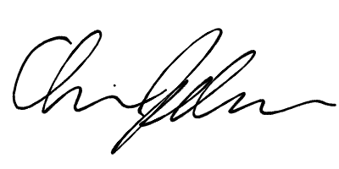
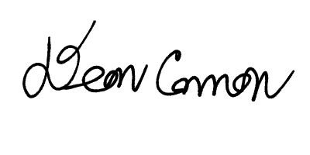
Vote: 27 - 0 - 0 (Yays-Nays-Abstentions)

______________________ ______________________
Deon Canon
President
Stout Student Association
Christopher Johnson
Vice-President
Stout Student Association

