Title: Organization Approval – Interactive Meme-dia

Whereas, Interactive Meme-dia has petitioned to the Stout Student Association Organizational Affairs Committee to become a Recognized Student Organization;

Whereas, Interactive Meme-dia has completed all necessary tasks to become a Recognized Student Organization;

Whereas, the purpose of Interactive Meme-dia is to “We wish to create an environment for learning through the consumption of new types of media that those in our organization might not have explored on their own. In doing so we hope to expand and give those who participate a greater understanding of media to use as a creative bounce board in their own studies or choice of career.”

Whereas, Interactive Meme-dia will give UW-Stout students a special opportunity for students to consume and discuss media in different forms. This can help students explore different varieties and forms of media.;

Be it therefore resolved, we, the U.S.S. of the S.S.A. approve Interactive Meme-dia as a Recognized Student Organization for the remainder of the 2019-2020 academic year.

Date acted upon: March 3, 2020

Action: PASSED

Vote: 19 - 0 - 0 (Yays-Nays-Abstentions)

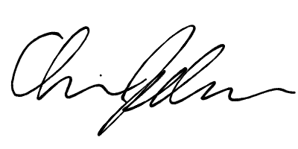
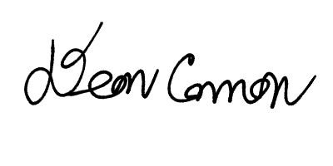

______________________ ______________________
Deon Canon
President
Stout Student Association
Christopher Johnson
Vice-President
Stout Student Association

