Title: Organization Approval – Entrepreneurship Club at University of Wisconsin-Stout

Whereas, Entrepreneurship Club at University of Wisconsin-Stout has petitioned to the Stout Student Association Organizational Affairs Committee to become a Recognized Student Organization;

Whereas, Entrepreneurship Club at University of Wisconsin-Stout has completed all necessary tasks to become a Recognized Student Organization;

Whereas, the purpose of Entrepreneurship Club at University of Wisconsin-Stout purpose is to provide “Opportunities for professional development through the practice of entrepreneurship. An entry point for involvement in the entrepreneurship and entrepreneurship activities on campus. Opportunities to start, manage, and grow student-run businesses.”;

Whereas, Entrepreneurship Club at University of Wisconsin-Stout will give UW-Stout students a place to develop Entrepreneurship skills with this it will also give them more leadership opportunities to help them develop these Entrepreneurship skills;

Be it therefore resolved, we, the U.S.S. of the S.S.A. approve Entrepreneurship Club at University of Wisconsin-Stout as a Recognized Student Organization for the remainder of the 2019-2020 academic year.

Date acted upon: March 3rd, 2020

Action: Passed

Vote: 18 - 0 - 0 (Yays-Nays-Abstentions)

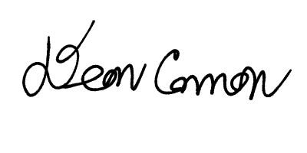

______________________ ______________________
Deon Canon
President
Stout Student Association
Christopher Johnson
Vice-President
Stout Student Association

