Title: Updating the Bylaws and Constitution

Whereas, the Bylaws and Constitution of the Stout Student Association needs to be updated;

Whereas, the Bylaws and the Constitution of the Stout Student Association are living documents and should reflect modern standards and modern practices;

Be it therefore resolved, we, the U.S.S. of the S.S.A. approve the Bylaw and Constitution edits brought forward by the Governing Documents Special Committee.

Date acted upon: April 15, 2020

Action: PASSED

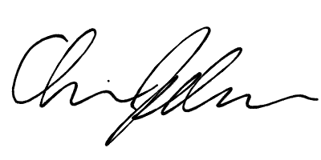
Vote: 24 – 0 – 0 (Yeas-Nays-Abstentions)
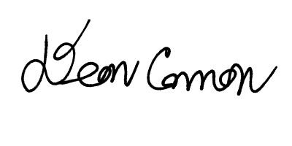

______________________ ______________________
Deon Canon
President
Stout Student Association
Chris Johnson
Vice-President
Stout Student Association

