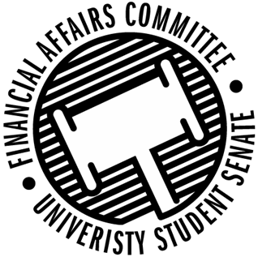

Meeting Agenda
3:30 PM White Pine Room, Memorial Student Center
50th Congress December 13th, 2019
- Call to Order
  - 3:34PM
- Roll Call
 | Present | Absent | Excused
Director Gentz | X
Vice Chair Halbach | X
Vice President Johnson |  |  | X
Senator Dumke | X
Senator Kleinschmidt | X
Senator Korte | X
Senator Penoske |  |  | X
Senator Reindl | X
Advisor Lee | X

- Words of Wisdom
  - Senator Penoske, next meeting
  - Director Gentz
    - “Don’t trust the state.” – Gary Ramos
- Approval of the Minutes
  - 12-6-19
  - Approved
- Approval of the Agenda
  - Approved
- Unfinished Business
  - Senator Dumke motioned to amend roll to add Senator Korte, 2nd by Halbach
    - Approved
- New Business
  - Rollover Requests
    - SSA
      - Motion to postpone by Halbach, 2nd by Korte
        - Approved 5-0-0
  - Reallocation Request
    - Wrestling Club
      - Motion to approve by Dumke, 2nd by Reindl
      - Approved 4-0-1
  - New Member Training
    - Introduced new members to how the budget processes work and how organizations can request money.
  - Sport Clubs Commission Update
    - Update from Advisor Lee
      - Sounds like there was a miscommunication between business office and sports clubs
    - Director Gentz had followed up with the concerned student about sport clubs not paying officials
      - Sounds like there had been no resolution.
    - Advisor Lee’s update was more recent than Director Gentz and it sounds like the referee’s will be paid soon.
- Announcements
- Adjourn
  - Moved to adjourn by Dumke, 2nd by Kleinschmidt
  - Approved 4-0-1

