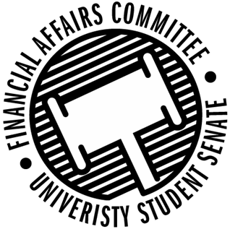

Meeting Agenda
3:30 PM White Pine Room, Memorial Student Center
50th Congress November 1, 2019
- Call to Order
  - 3:34 PM CDT
- Roll Call
April 12, 2019 | Present | Absent | Excused
Director Gentz | X
Vice Chair Halbach | X
Senator Dumke | X
Senator Penoske | X
Advisor Lee | X

- Words of Wisdom
  - Senator Penoske
    - “Rise early, work hard, strike oil.” -J. Paul Getty
- Approval of the Minutes
  - 10-25-19
  - Dumke moves to amend the minutes to say the correct date, Halbach 2nd
  - Approved
- Approval of the Agenda
- Unfinished Business
  - Contingency 1 Budget
    - Approved Unless noted below
    - American Society of Mechanical Engineers
      - Representative came in to clear up our questions about determining whether it is equipment or event supplies
      - Motion to deny Event Supplies by Penoske, 2nd by Dumke/
        - Approved denial 3-0-0
      - Motion to approve Batteries, Speed Controller, and remaining amount up the cap for the motor and deny the rest of the amount requested for the motor.
        - Approved 3-0-0
    - IDSA
      - PSOUP Workshop, charging for the event
        - Motion to approve by Dumke, 2nd by Halbach
        - Denied 3-0-0
      - Fundraiser funded up to cap.
    - School Counseling Organization
      - Volunteer Opportunity
        - Could not fund gifts to Charity under policy paper 820
    - Model United Nations
      - Approved 790 instead 406 because a comment on the page was submitted and talked about before the hearing.
- New Business
  - Just-In-Time Request
    - Engineers Without Borders
      - Applied for event in contingency but did not sign up for a hearing.
      - Denied 2-0-1
  - Rollover Cap Discussion (Time Permitting)
    - Plan for next meeting to have members of BDP, SSA, and Stoutonia attend to discuss.
  - New Meeting Time
    - More discussion about moving to Mondays
- Announcements
- Adjourn
  - Moved to adjourn by Penoske, 2nd by Dumke
  - Approved 3-0-0

